The Voltage Divider
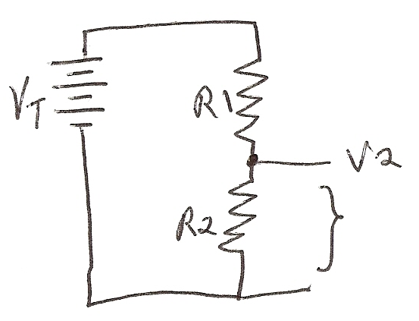
One of the most versatile circuits in electronics is called the voltage divider. It occurs in a variety of forms, but basically it involves apply in a voltage and having the circuit break it down to a smaller amount. The basic circuit is below.

The voltage V2 is some fraction of the applied voltage VT. From KVL we know that
VT= V1 + V2 and IT = VT/RT where RT = R1 +R2
Now, IT = VT
R1 +R2
So V2 = IT * R2
V2 = R2 * VT
R1 + R2

V2 = R2 *VT
R1 +R2
Applications of the voltage divider
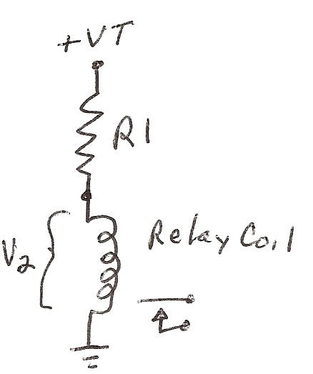
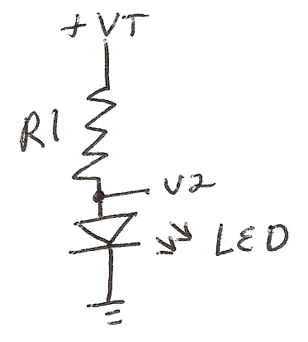

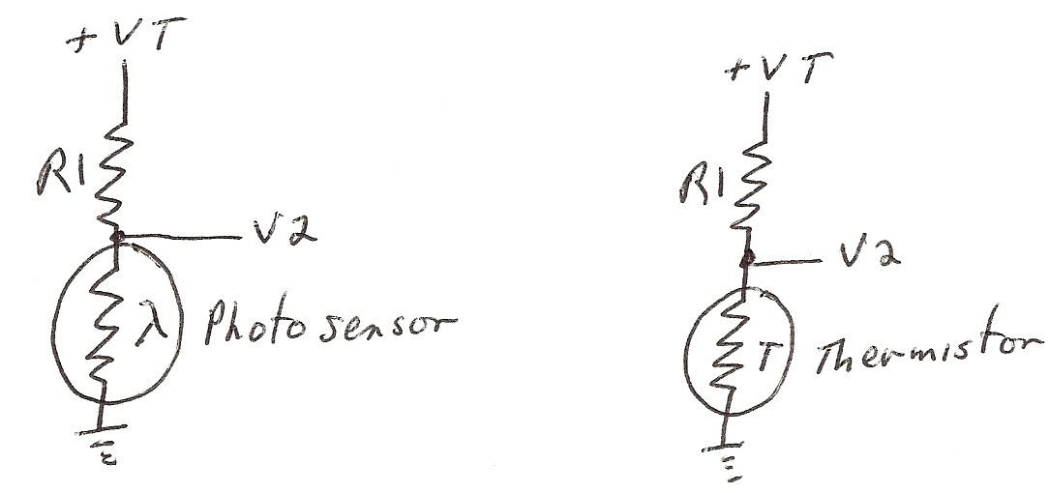

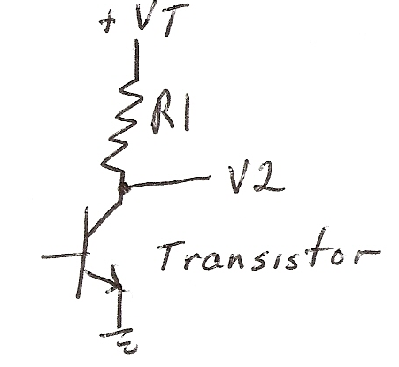
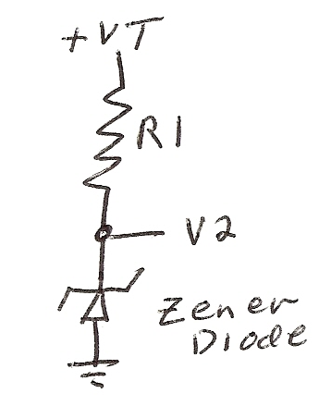

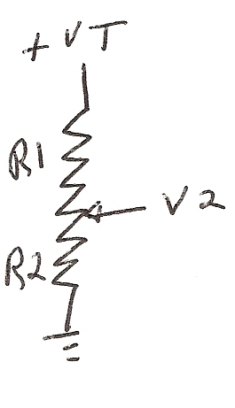
This last circuit is the volume control in radios, disk players, etc.
The zener circuit will establish a fixed voltage and is used in many power supply circuits. The photosensor and thermistor are used as computer input circuits. Finally the transistor circuit is the output stage of most amplifiers or driver circuits.

Dr. Cunningham © 2009

