Series / Parallel Resistor Combinations
In this experiment, we will select various resistors based on their color-coding,
then connect them into series an parallel arrangements.

Their total "net" resistance will first be calculated, and then
measured with the ohms setting on the digital meter.

The following equipment is required for this experiment:

• DMM (Digital-Multi-Meter) • Meter Leads
• Breadboard • Misc. hook-up wire • Various Resistors (Listed Below)

• Using the Resistor Color-Code and example in Figure 3-1
determine the "colors" for the following resistors:

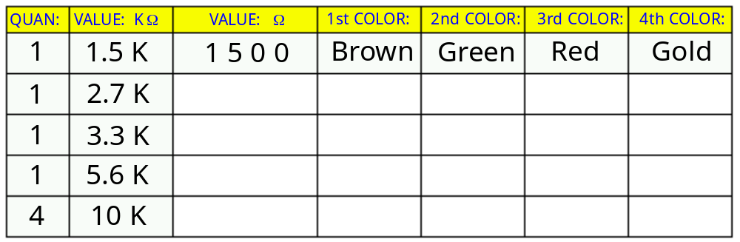

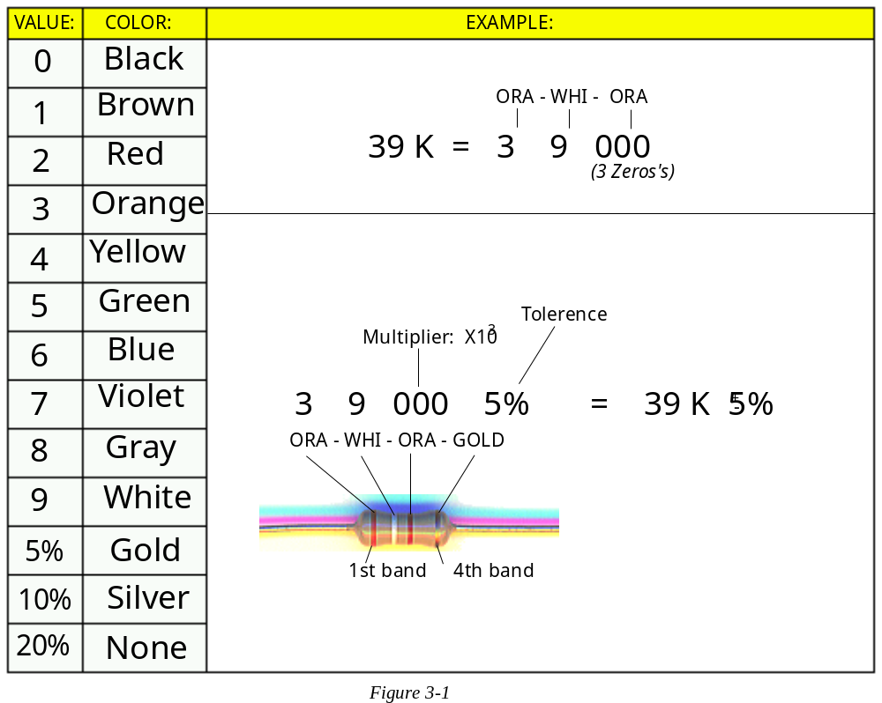

Introduction to Electronics Lab |  | EET103- | SECTION: |  | Exp #3: "Series / Parallel" | 
Name: |  |  |  |  | Date: | Page 1/7
Case-1 Two series resistors

• Before starting, select the 8 resistors from your chart on page-1

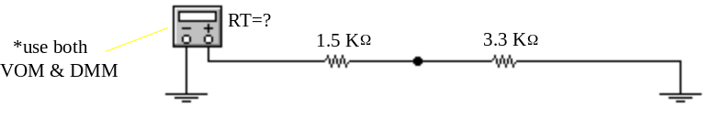

• First, calculate the Total resistance from the circuit above.

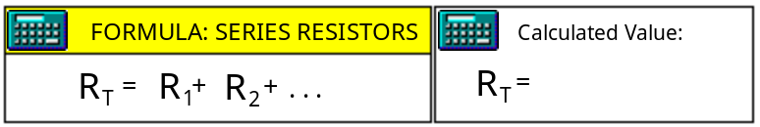

• Using the example in Figure 3-2, "breadboard" (connect) the circuit.

• Using the DMM, measure the circuits total resistance.

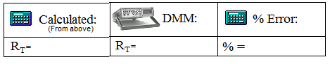

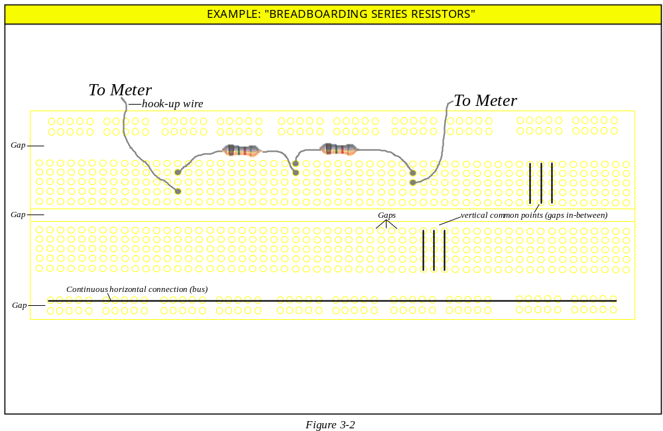

Page 2/7 | Introduction to Electronics Lab |  |  | Exp #3 "Series/Parallel Resistor Combinations"
Case-2 Two parallel resistors

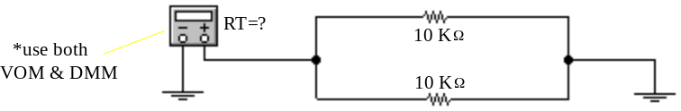

• Calculate the Total resistance from the circuit above.

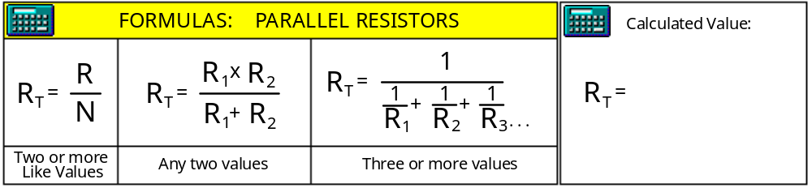

• Using the example in Figure 3-3, "breadboard" (connect) the circuit.

• Using the DMM, measure the circuits total resistance.

EMBED PBrush

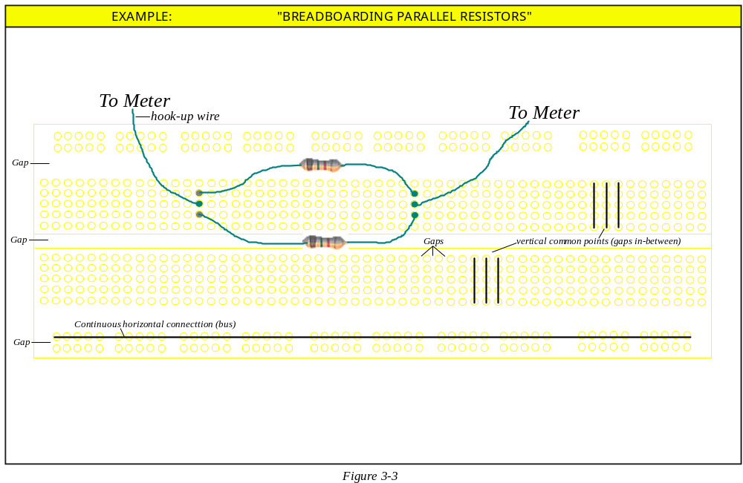

Introduction to Electronics Lab |  | Exp #3 "Series/Parallel Resistor Combinations" |  |  |  | Page 3/7

