The Voltage Divider

The Voltage Divider circuit is very heavily used in Electronics.
Below is the standard wiring configuration for voltage dividers.

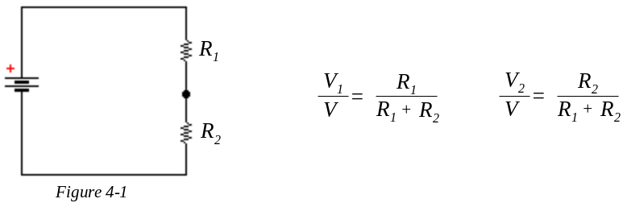

Note that the voltage on either resistor has the same ratio to the total voltage
as the resistor has to the total resistance.

We shall investigate this behavior in several simple circuits.

EMBED MSDraw \* mergeformat

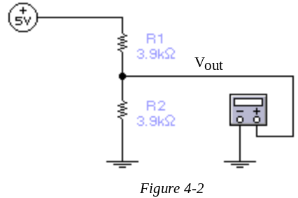



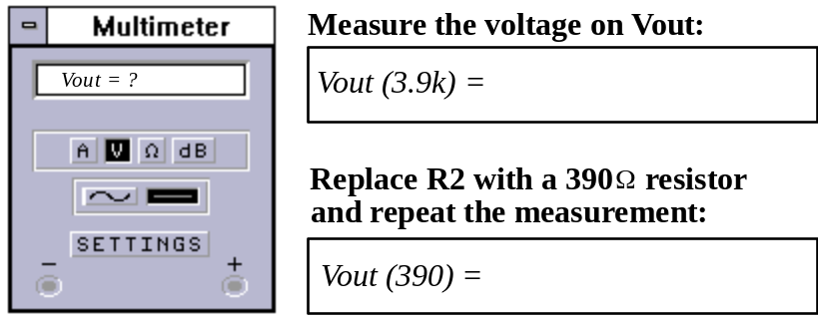

F This should yield a 10 to 1 ratio (10:1) in the voltage Vout.

Introduction to Electronics Lab |  | EET103- | SECTION: |  | Exp #4: "The Voltage Divider" | 
Name: |  |  |  |  | Date: | Page 1/2
Now, replace R2 with the photoresistance cell.

This is a resistance wire embedded in cadmium sulfide material.
This material will, (when exposed to light),
increase its conductivity. (decease its resistance)

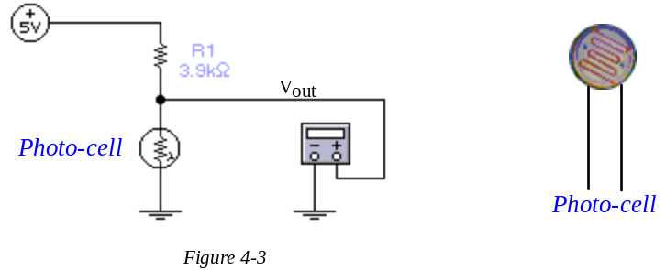

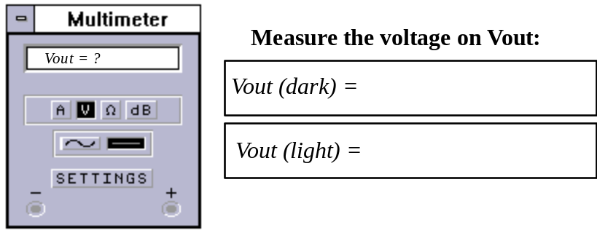

In later experiments, we will show how this voltage can be used to turn on or off devices.
This is the basic action of the small photoswitches used to control street lights,
or devices used to control house lights, when on vacation.

Page 2/2 | Introduction to Electronics Lab |  |  | Experiment #4 "The Voltage Divider"

