Introduction: Electrical and Electronic Systems

All electrical and/or electronic systems can be viewed as a collection of smaller systems each doing one simple thing. In this course we will study both the smaller systems and in selected cased how these can be assembled into larger systems.

  - The Toaster

One of the common electrical systems found in most homes is the electric toaster. The operation is reasonably simple. After inserting the bread the lever is pushed down and a switch is closed that allows the electrical current to move through the toaster wires. These wires are made of a material that will get very hot as can be seen from the red glow of the wires. This causes a charring of the bread surface. As the temperature rises, a thermal sensitive switch is thrown and opens the circuit causing the heating operation to stop. The electrical circuit would be shown below:

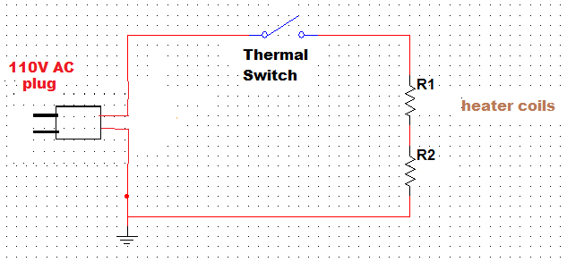

Figure 1.1: Toaster Circuit

The toaster shows the basics of an electrical control system. The operation is started by pushing down the bread. The process is the charring of the toast. As the charring occurs the thermal switch is the measurement element sensing the temperature being achieved in the process. Finally when reaching the desired “set point Temperature” as set on the lightness/ darkness dial, the control element, the switch, opens and ends the operation.

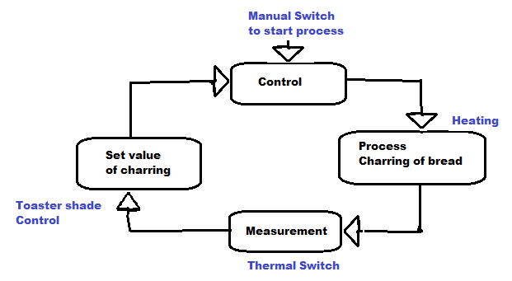

Figure 1.2: The Electrical Control System

  - The Radio

A common electronic system is the radio. Whether an AM or FM radio the systems operation is the same. First a means of collecting the signal from the radio station is needed – the antenna. Then a circuit must select from the many stations available the single one desired – the tuning circuit. The result of this operation is sent to the amplifier to make it ‘loud’ enough to hear and finally a speaker to change the electrical signals to audible sound waves.

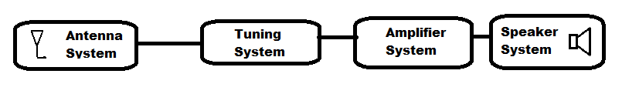

Figure 1.3: Radio system diagram

0.3 The Cell Phone

One of the most commonly used new electronic devices is the cell phone. The cell phone could be described as a system made from the radio system above. The system above could be represented as a single block.

Figure 4 shows one possible description of the cell phone system.

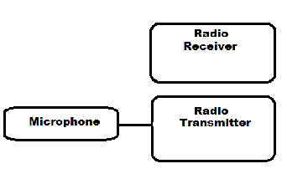

Figure 1.4: Cell Phone System Block

Each of the systems blocks consist of a collection of smaller systems until we are at the discrete components. For example the radio receiver has many sub systems as described above. In this course we will study the individual components and how they interact to build circuits and move to more and more complex systems.

1.0 Charge and Current

1.1 Exploration: Charge
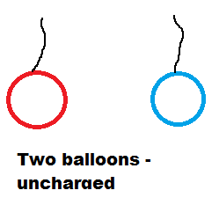
The concept of charge has been around for thousands of years. However, it was not until the 1700s that real scientific investigation began on what it was and documenting of how it seemed to work.
Blow up two of the rubber balloons in your parts kit and tie a short (4 to 6 inch) string on each. Don’t go overboard on blowing them up, about the size of a small melon will do nicely. Hold the two balloons by their strings and notice they hang straight down with no influence on each other (Fig 1.5). Now, rub

Figure 1.5: Uncharged balloons

one on your shirt and hold it by the string. Hold the other by its string and bring them close together but without touching. They should pull together (see fig 1.6). Next, rub the second balloon the same way and repeat the process. This time they should push apart (see fig 1.7). (This works best if your shirt happens to be a wool sweater!)

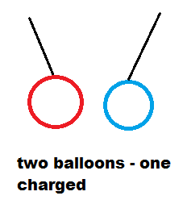

Figure 1.6: One charged balloon - pulling towards each other.

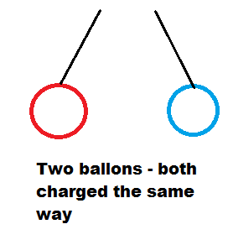

Figure 1.7: Two equally charged balloons – pushing apart

1.2 Dialog: Law of Charges

In the case of uncharged balloons, there is no interaction between the balloons. But if one is charged it will attract the second. In the third case the balloons had equal treatment and they repelled each other. This leads to the conclusion they may be two “kinds” of charge. In the case of one charged balloon, the charged balloon will “induce” a charge on the second balloon’s surface by attracting to the surface those charges that are on the balloon (see fig. 1.8). This leaves the opposite side of the balloon with less charge.
But, in the third case both balloons have nearly equal and identical charges and they repel each other. Thus the charges being attracted in the uncharged balloon are of a fundamentally different type than in this last case.
From these and similar experiments it was deduced that there are two different charges with definite properties. Ben Franklin dubbed these charges as Positive and Negative. If a substance has equal amount of + and – then it is neutral or uncharged. However, as in the second case above these charges can be temporarily separated to produce the induced attraction shown.

Law of charges:
Like charges repel.
Unlike charges attract.

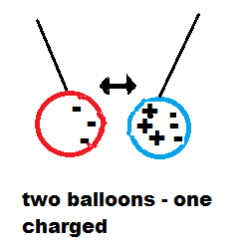
Figure 1.8: Position of charges in case 2.

Note that the blue balloon is still neutral as it has equal numbers of charges but they have been forced apart due to the electrical force from the red balloon. The red balloon has an excess of negative charges gathered from the rubbing of the shirt.

These are examples of static charges. The charge is confined to a surface and is unable to move or to contact the opposite charge on the second device. As static charge they can exert force, as shown by the balloons moving toward each other. But, no significant work is done. In a circuit we use conductors ( a device that allows the movement of charge). When the Law of charges is applied to the circuit, as in the toaster, the charge can move through the metal conductor we obtain a more dynamic behavior. When charge is in motion we call it a current.
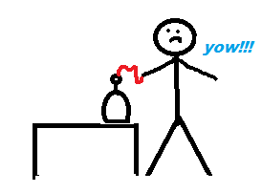

1.3 Exploration: Current

Electricity is invisible. We cannot use our senses to make a quantitative measure of its size. Although in the early days it was common for an experimenter to determine the presence of electrical activity by getting a spark to jump to their finger. This is neither a practical or safe way to “sense” electrical activity.
A multimeter is a device for measuring in a quantitative way the presence and quantitative size of electrical activity. Connect the circuit below with two pieces of wire inserted into a cup of tap water. Be sure to strip the insulation from the wires where they are in the water.

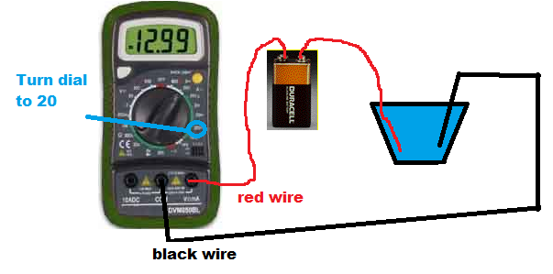
Figure 1.9: Charge Movement Circuit

Be sure the meter dial is set to the location shown (20 mA). Take a reading on the meter it may be nearly zero depending on your water supply.
Take a salt shaker and place a small amount of salt in the palm of your hand about the size of a dime. Add the salt to the water and stir a little. Again take a reading.
Is it larger? _________________________
Repeat this process at least 5 times.

Data Table
Trial ( number of salt drops) | Multimeter Reading
0
1
2
3
4
5

1.4 Dialog: Atoms and Ions

Salt is made of two elements sodium and chlorine. When placed in water it breaks into these elements but with an electrical charge. The sodium is positively charged and the chlorine is negative. The battery will attract the negative charges to the red lead and the positive charges to the black lead. This is due to the concept of unlike charges attracting and like charges repelling. In other words the positive charges of the battery will attract the negatives in the water solution and the negative charges of the battery will attract the positive charges of chlorine.
As the amount of salt increases more charges are available to move and the meter will read a higher value of charge movement.

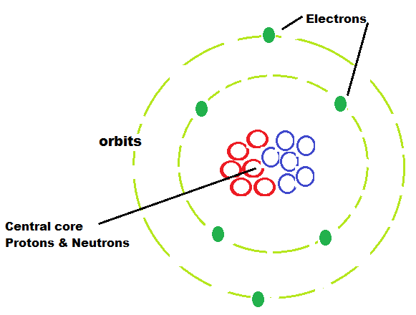
In the early 20th century a physicist, Neils Bohr, proposed a very useful model of the atom. In this model the atom consists of a dense central core that is made up of positive charged objects and neutrally charged objects called protons and neutrons respectively. Moving about this core are negatively charged objects called electrons. The electrons move on elliptical orbits similar to the movement of the planets about the sun. Although this is a very simplistic way to view the atom, it is a helpful model for our purposes and does not produce conflicting results for more advance models.

Here the red circles represent the protons and the blue circles represent the neutrons. Combined this would represent the carbon atom. The six green dots represent the electrons. Since the atom has six positive and six negative charges the atom is over all neutral in charge.

If one of the electrons were removed from the atom it would have an overall positive charge and would be considered an ion. An ion is an atom or molecule (cluster of atoms) that has an overall charge either positive or negative.

The sodium and chlorine in the water are called ions. In solutions this is the common means of charge transport. We call this movement of charge a current. The definition of current is the amount of charge to flow in any given second of time. The basic unit of charge is called the Coulomb and one Coulomb per second is a current of one Ampere. The Coulomb (C) is made of 6,200,000,000,000,000,000 electronic charges either positive or negative. This is better expressed as 6.2x10¹⁸ charges. We use a large quantity of charge in any electronic operation. This is similar to selling apples, where the farmer prefers to sell them by the bushel, rather than one apple at a time.

Unit | Physical Quantity | Abbreviation | Math Symbol
Second | time | s | t
Coulomb | electrical charge | C | Q
Ampere | current | A | I

The t for time is obvious, the Q stands for quantity of charge, and the I for Intensity of charge. Recall the note earlier that talked about the early experimenter who made measurements as a spark – intense sparks meant lots of current.

The mathematical relationship is : I = Q/t

When establishing the laws of charge movement, researchers did not know which type of charge was in motion. Did the negative move through the wire or did the positive move through the wire. So, it was decided that the charges moved in a wire from the positive to the negative. This is call the “conventional current”.

In free space (that means a vacuum like space) the charges would move toward each other. The electron would move the most as it is about 2000 times lighter that the proton. When confined to a wire, the movement is caused by electrons as they are the charge that is able to move about. The protons are contained within the atom itself and are restricted in movement. When one Coulomb of charge moves past a point in space in one second of time, this is defined as one Ampere (A) of current. In 1911the size of the charge was established.

In the Bohr model of the atom the negative charges were the charges capable of moving. This innovation lead to some people using the direction of the current as the flow of the electrons. The problem arises in that all the electronic symbols, diagrams etc. are drawn by scientists and engineers who happily use the conventional current (flow of positive charge). Their equations etc. are set up assuming a positive charge in motion. Now in reality it makes no difference, but if one uses the negative charge as the reference a lot equations have to be modified to have a negative sign in them to account for the negative charge. Plus in solutions both types of charge can be in motion. In electroplating, for example, the metal ion is positive. If it did not move, no metal would be deposited.

In this text we will assume the conventional current approach, hence current is the direction of flow of a positive charge. This is consistent also with the diagrams in Multisim. This also puts us in agreement with the symbols used for the solid state devices we will encounter. Again, the results are the same, as in reality, the charges move only a very short distance in metals (on the order of micrometers). It is the influence of their electrical force that moves rapidly (2/3 the speed of light) through the circuit.

1.5 Applications: Examples of the Charge - Current Relationship

The following are three example problems representing the type of situations that can arise with the charge - current relationship. Solutions will follow the problems.

- A device has a charge of 8.6 Coulombs travel through in 10 seconds. What is the current?
- A current of 12 Amperes is maintained in a battery charging operation for 30 minutes. How much charge is transferred?
- It is necessary for a process to move 1.6 x10⁻³ C. If a maximum current of 1.5 x10⁻² A is possible, how long will it take?

You may want to refer to the Appendix for the paper titled “How to Solve Problems Like a Pro” for hints on solution methods. There is also an appendix on use of powers of 10 and the metric prefix for units.

Final note:

The current is a rate quantity. Rate is a common physical measurement. Whenever we use rate, it is to measure one quantity against another. This ratio results in a new quantity. For example, we have a gage on the car that tells us miles, but when we find MPG , this is a totally new concept. Imagine if the car had a mileage rating like “This car is good for 10,000 miles, instead of 30 MPG.”

Solutions:

- A device has a charge of 3.6 Coulombs travel through in 10 seconds. What is the current?

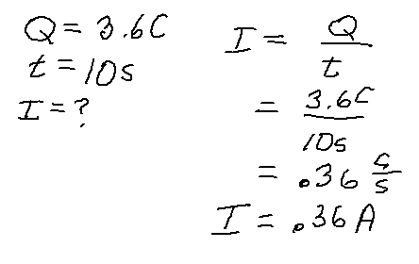

- A current of 12 Amperes is maintained in a battery charging operation for 30 minutes. How much charge is transferred?

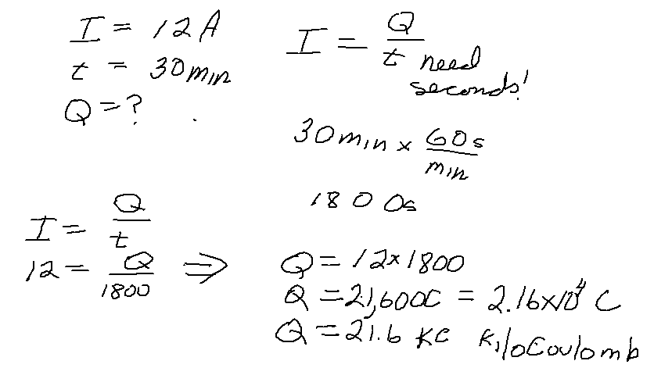

- It is necessary for a process to move 1.6 x10⁻³ C. If a maximum current of 1.5 x10⁻² A is possible, how long will it take?
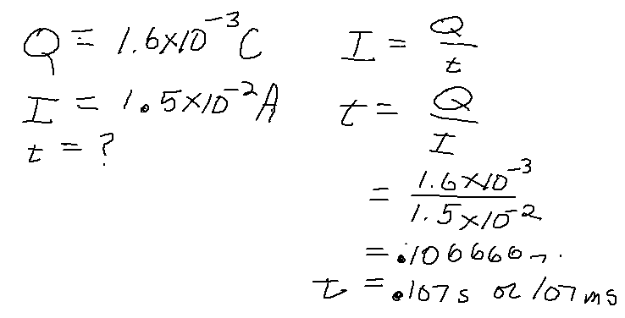

Additional Problems
:
- A battery has a total charge of 38 C. Assuming we could remove all this charge, how long could we sustain a current of 25 mA?
- A charge of 16 mC passes through a device in 4 ms. What is the current?
- A device is holding a static charge of 2 Coulombs. How may charges would this require?
- A current of 6 A is used to charge a car battery for 8 hours. How many Coulombs are transferred?

1.6 Exploration: Potential Differences

For this activity you will need three AA batteries, clip leads, digital multimeter and the small bulb in the kit several metal paper clips and thumb tacks, and a small piece of cardboard.

One means of rating the battery is a quantity called voltage (V). The AA battery is rated at 1.5 V, but that may vary with age and use. Using your multimeter set its range at 2 V and measure the reading for each of the three batteries. Use tape to label the batteries as A, B, C.

Battery | Reading in Voltage
A

B

C

Using your paper clips, thumb tacks and cardboard base, set up the arrangement shown in the photo below.

The arrangement allows the three batteries to be in what is called a series connection. Measure the voltage at the each point listed below: For each measurement below place the black lead is on the first numbered connection.

Measure between | Digital Meter  Reading
1 and 2
1 and 3
1 and 4
2 and 1
2 and 3
2 and 4

Questions:
- How is the reading on 1 and 2 different form 2 and 1?

- How is 2 and 4 related to 1 and 4?

1.7 Dialog: Voltage, Work and Power

The measurement of voltage is related to the energy available from the battery, but with a twist. Each of the physical quantities voltage, work, energy and power are related but fundamentally have a different purpose. It is possible to have a great amount of energy available but no work being done. The definition of work from Physics is the force on an object times the distance through which it moves the object. The definition is
W=F x D
As for units this would be force in Newtons and distance in meters
For Newton x meter = Joule (pronounce jewel) This is the unit of work in honor of James Prescott Joule for his studies in work and energy.

The Joule is a quantity of work we can experience. Lifting a package of 10 hotdogs (12 oz, 0.75 lb, 3.3 N) a distance of 1 foot ( 0.3 m) will result in 1 Joule of work being done.

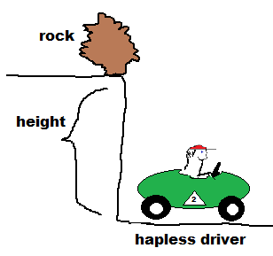
We must have movement to have work. Force is not enough for work. But it is enough for energy. In electronics if we have two charges one positive one negative. In the figure, if in a vacuum, the positive is a proton and the negative is an electron. The electron would move toward the positive because the negative is about 1/2000 of the mass of the proton.
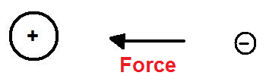
If the electron is not free to move, there would be the “potential” to do work. This is called a potential energy. The mechanical analogy would be to consider a large rock on the edge of a cliff. It does not move, but if it did a great deal of work would be done. The magnitude of work would depend here on the size of rock and the distance to fall.

The magnitude of the electrical potential energy would depend on the amount of charge and the distance apart. More charge, more force and more potential to do work. In electronics we use the term electrical potential. This is what exists between the leads of a battery. This electrical potential is a measure of the amount of work that could be done by a charge of one coulomb, or Potential = Joule/Coulomb. The unit of this ratio is called the Volt (after Alessandro Volta). Notice this potential is not directly energy or work but the amount we would get per unit of charge involved. This is another ratio type quantity or

V= J/C

As the charge moves several things will happen. First, a current is established or charge per time, and work will be done as the charge moves. If the current is 1 Ampere and lasts for one second, the amount of charge would be one Coulomb. If the electrical potential is one volt, then

1 Volt x1 Coulomb = 1 Joule or W=V x Q

This would be the energy necessary to move the charge. If we moved the charge, then it was the work done. If we moved 0.5 Coulomb with 2 V, we would still use 1 Joule of energy and do 1 J of work..

2 V x 0.5 C= 1 J

Now in our exploration above the voltage was greater the more batteries we connected. Here the mechanical analogy would appear as below

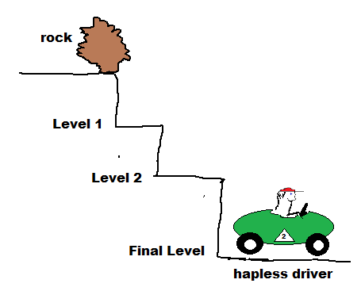
The rock might stop at any level and the work done would be less that the total energy available at ground level.

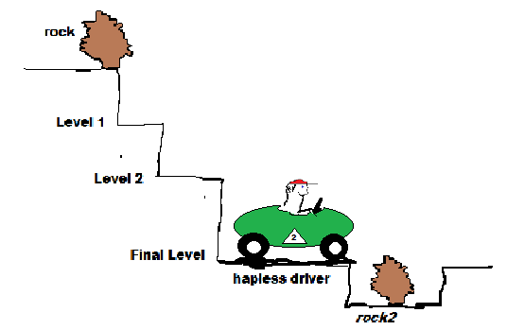
In our exploration as we add batteries, we gain the potential energy. This is of course with respect to the black lead of the meter – we will call this ground. Now in electrical systems we can have voltages above and below ground. The below ground situation will show up as a negative reading.
Short of an earth quake rock 2 will not provide energy to the car as their is no force to move it upward. But in an electrical circuit we can have below ground level situations.

This can show up in an electrical circuit as below with three 1.5 V batteries. (For a list of electronic schematic symbols look to the appendix.)
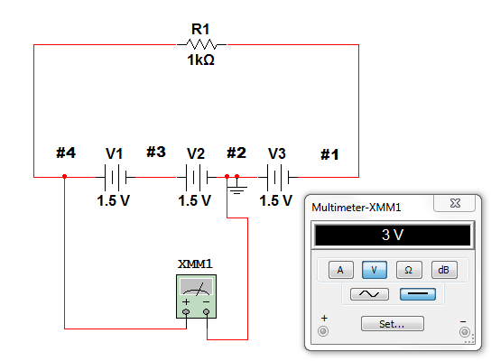

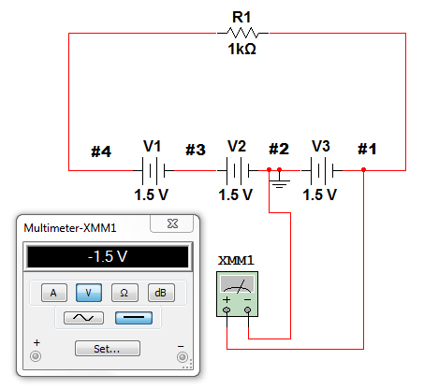

Your reading from position 2 and 4 should match the above reading. Note the negative lead of the meter is connected to the #2 position also the ground connection. When measuring from #2 to #1 as at right, the voltage will be 1.5 V and negative or below ground. This circuit configuration is called a dual polarity supply.

1.9 Resistance

Introduction
A resistor is a device for controlling the amount of current that appears in a circuit. In most electronics circuits the voltage is a constant quantity (like from a battery). When it becomes necessary to reduce the voltage to part of a circuit or control the amount of current a device can receive a resistive device is used. This will often consist of a poor conductor like carbon or a long length of wire (called a wire wound resistor). Newer devices are being made of very thin metal films (thin film resistors).

Exploration
To gain a “feel” for how these devices behave we will do a small experiment. Connect the circuit below with your 9V battery, a variable resistor, and a 1500 Ohm fixed resistor. The resistor can be spotted as having three color bands brown, green and red on its body. Don’t worry yet about what the Ohm unit means, it will become clear as we do the experiments

In Electronics, use is made of simplified drawings known as "schematics"
These schematics are designed to show the electrical connections between the varying circuit elements. A complete set of diagrams may be found in the appendix section.

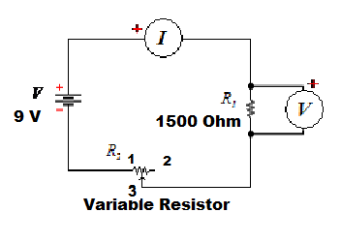
A word or two about the variable resistor is in order at this point. A variable resistor has a contact at each end as all resistors do, but it also has a “tap” point in the middle. If we use only one end and the middle it is called a rheostat and, as here, adds resistance to the total circuit. In this function it is intended to give manual control to the amount of current that will flow. If all three leads are connected to the circuit it is referred to as a potentiometer. In this function it is providing variable control to the voltage at the center tap point. The pictures below provide some examples of two such devices.

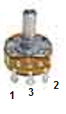
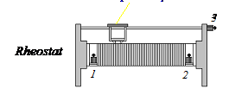

The 9 V battery was originally designed to run transistor radios. Today they are used in a wide variety of devices from smoke alarms to calculators.
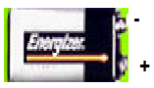You will use the clip lead wires to connect to the battery. You may use your multimeter to check the polarity of the battery terminals.

The fixed resistor is about the diameter of a ball-point pen filler and will have 3 to 6 bands of color. You want to look for the one with Brown, green, and red bands in that order. The device has no polarity and can be connected in the circuit in any orientation. The photo below should provide some guidance to making the connections. As most will have only one meter the voltage and current reading will need to be taken sequentially. One photo below shows connections for the voltage reading the other for the current reading.

Connect your circuit and set the rheostat to middle range of its turn radius and place your multimeter in series in the circuit to measure the current. Touch to the battery and get a current reading. Then take out the multimeter and replace it with a clip lead. Switch your voltmeter over to read voltage and connect it to both sides of the resistor. Again quickly touch the power to the circuit and take a voltage reading. This action is necessary since we only have one meter at home. But, as it is a multimeter, we can do both operations. (You should see about 1 to 2 mA and about 3 V.) Record your readings below.

Ohm’s Law relates the ratio of voltage to current in the following manner

Resistance = Voltage / current or R= V/I

The equation can be rewritten as a straight line equation V= I R. In this form we can apply the “magic circle” to help with the algebra.
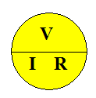
By covering the desired value when the other two are known we can see if we multiply or divide to get the desired result.
It is a simple aid that you will outgrow as you progress in the study of electronics.
Fill in the charts below with your values.

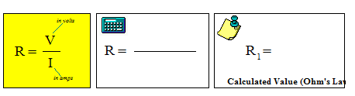

Now disconnect the fixed resistor from the circuit and connect the multimeter to the resistor. When the circuit is connected to voltage, we must never measure resistance with our multimeter. It will probably ruin the meter ($ouch$). Set your Ohms scale to 20 K and record the values below.

Measured value | Value from above | % difference

Another way to view Ohm’s Law is to collect a series of values and draw a graph.
As we increase or decrease the charge flowing into a resistor, the VOLTAGE across that resistor will change also. However, for a fixed device the ratio will remain the same. This relationship is governed by Ohm's Law. To demonstrate this, we will leave the supply voltage (VT) at a constant 9 volts. (Not much choice since it is a battery.) We will then incrementally increase the flow of charge (current) through the 1500Ω fixed resistor R1 - by adjusting the Rheostat R2 we will observe the current flowing through R1 - While also noting the Voltage drop across R1. The process for this is the same as above. Adjust he rheostat, read the current, move the meter to the voltage position and read the voltage. Record these values below.

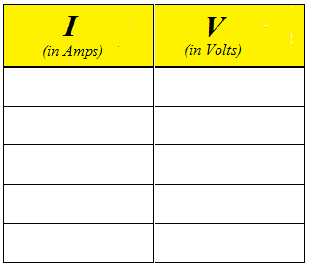

Plot this data in the graph below and sketch the best straight line through it you can.
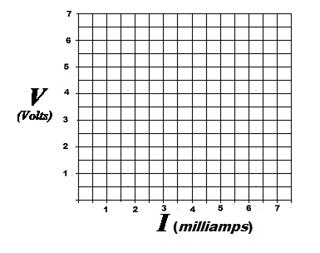

To measure the slope of a line once the quantities are measured,
start by picking two points on the graph. (see below)

The Δ is read as "change in". Another definition of slope is "rise over run"
This refers to the length of the sides of the triangle as seen below.

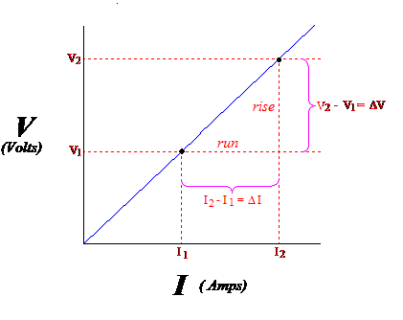

Record you values below:

ΔV | ΔI | Slope (R)

Compare this to the known value of the resistor (1500 Ohms or 1.5K ohms)

Slope Value | Known Value | % error
 | 1500 or 1.5K

Dialog:

This experiment adds another layer to our understanding of Ohm’s Law behavior. From a graph one can determine if a linear relation exists between two quantities.
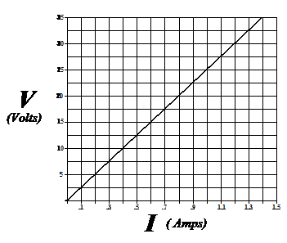

Here we see a graph of a straight line of voltage and current. Using the techniques in the lab we can say that the resistance is 25 Ohms based on the points 0,0 and 0.4.10.

This linear behavior is described by the equation

Y= mX + b

In our application this would be

V = I R + V_{o}

The Vo term is the intercept value. In our graph this is 0 Volts. So we are left with

V= I R The classic statement of Ohm’s Law.
Devices with this linear behavior are said to be Ohmic devices. Here the resistance will be the same at all values of either voltage or current.

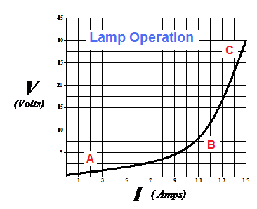
This is not true for many special devices. These devices are called non-ohmic. One example is a light bulb. Because of the heat generated by the bulb’s operation, the resistance will be higher in operation than when off or cold. Hence, the resistance (or slope) will not be the same.

The graph at the above is for a 30 V bulb, note that the resistance at point A is very low as shown by the slope of the line at that point. As the voltage moves toward proper voltage at point B the slope is steep, hence higher resistance.

At point C the resistance has reached its final value at operating voltage. In a bulb this can be a change of up to 10 X.

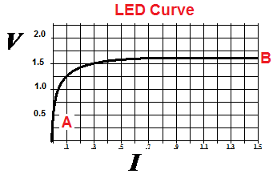
The Curve at the left is for a Red Light Emitting Diode. On this device at point A the resistance is very high and very little current will flow. At about 1.5 to 1.6 V the voltage will no longer increase but the current can increase.

Neither of these devices are Ohmic as they are non linear. Although you can apply Ohm’s Law to find a resistance it is only valid at that single set of V and I and is not generalizable to all conditions of the circuit. For the LED in fact, the current is not controlled at all by the Ohm’s Law. Looking at the graph you can see that the current could be a wide range of values for a given voltage. We rely instead on a series resistor to control the current through the LED. This will be covered in a later section.

Application: Current in an LED

In your kit you should find a red LED. Connect it into the circuit shown below and use you multimeter to determine the current and voltage the LED operates under for each value of R1 in the data table.

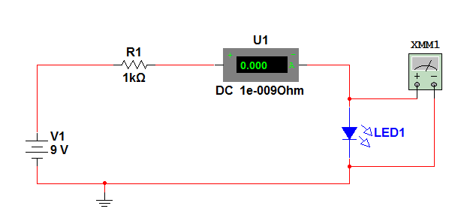

R1 | V_{LED} | I_{LED} | Effective R_{LED}
1000 Ohms
820 ohms
470 ohms
270 ohms

Questions:
- Are the resistance values for the LED constant? Yes No
- Would you describe the device as ohmic or no-ohmic?
- Can you discern a difference in brightness for the LED at different currents?

Application: Problems

- An LED needs 2.2 V at 10 mA for proper operation. It is desired to operate this form a 24 V battery. What size resistor should be used to drop the unwanted voltage?
- Typical red LEDs require 1.5 V for proper operation. To operate this on a 9 volt battery will require what size resistor? ( Assume a 6 mA current.).
- A light bulb in a car tail light uses 0.25 A. The battery is, of course, 12 V. What is the resistance of the filament in the bulb (under these conditions)?

1.10 Combinations of Resistors

In many applications the technician will use a combination of resistors to achieve a desired result.
There are two major types of basic combinations called series and parallel. In the following sections we will explore both types of combinations.

Series Circuits

In nature there is the concept of conservation. This doesn’t mean saving trees and fishes (although a noble cause), but the fundamental laws of Physics:
- Conservation of Energy
- Conservation of Charge
Even Einstein didn’t dispute the conservation of energy, he extended it to include that mass and energy are interchangeable through E-mc² . In any closed system (that means no outside influence) mass/energy remain constant. It can change forms, but it is neither created nor destroyed.
Similarly charge in a closed system is constant. If I pull an electron (- charge) off an atom, the atom is left + charged for a net change of zero! There is nothing that “eats” or “spits” charge. So if a device is neutral to start, and 10 electrons go into the device, 10 electrons must come out. They cannot just disappear! If we remove charge form one terminal of a battery, we must add charge at the other terminal to maintain conservation of charge. Now, it does not have to be the exact same charge. We don’t have yellow, green and blue electrons. They are not like M&Ms. All electrons are equal. The charge actually moves very slowly through the wire ( about 10⁻⁶ meter/sec). But, the effect is felt very quickly, near the speed of light (300x10⁶ meter/sec). This effect is the electromagnetic field. The same phenomena that projects our radio and TV across empty space. In a section of TV coaxial cable the speed is about 200x10⁶ meter/sec.
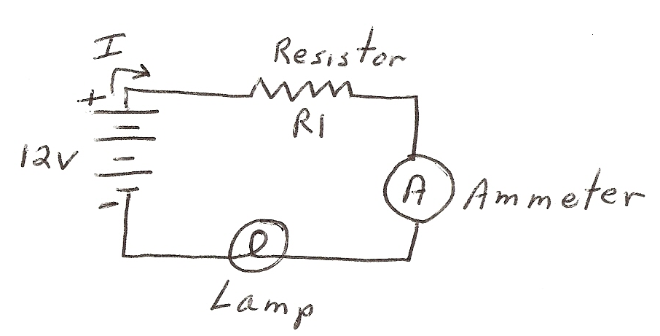
It is easy for us to use the simple model of thinking of the charge moving from one terminal to the other and the net result is the same if a marked charge really did move along that path. The Physics of the situation is that the field in the wire effects the charge all along the circuit.
Now, let us apply conservation of charge to a circuit.

If we take 1 Coulomb of charge from the + terminal of the battery and move it to R1, then 1 Coulomb must leave R1 and enter the ammeter! Similarly, the 1 Coulomb leaves the ammeter and enters light bulb. It then leaves the bulb and enters the – lead of the battery. One coulomb left the battery and one Coulomb returns to the battery – conservation of charge. Now, if we do this every second , then a current of 1 Ampere goes through R1 then the ammeter, and bulb returning to the battery. All parts of the circuit have the exact same current! This circuit is called a series circuit since the current must pass in sequence through each device . Therefore

I _{from bat} = I_{R1} = I_{ammeter} =I _{Lamp}

This is one form of a law developed by a scientist named Kirchoff. It is known as Kirchoff’s Current Law (KCL).

“Current into a point (or device) equals current out of a point (or device).”

This also makes it clear why we want to always put an ammeter in series with any device to measure the current value. That way all charge flows through the meter and is counted.
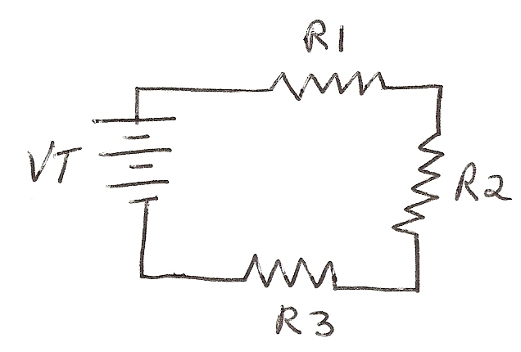
Similarly, let us look at a circuit from the energy stand point. Consider the series circuit before. If we remove 1 Joule of energy from the battery to move 1 Coulomb through the circuit, where will it be used? If we expended all the available energy in R1, there would be nothing left to move the charge through the circuit. We know this is not possible, so only a fraction of the energy will be used to “push” the charge through R1, a fraction for R2 and a fraction for R3. When the charge returns to the battery, the energy will be expended. Since voltage is Joule/Coulomb, for a fixed charge value the voltage is related directly to the energy. Since the voltage VT is the available electrical potential then

VT = V1 + V2 + V3

Is a statement of energy conservation. This is also known as Kirchoff’s Voltage Law (KVL). Each of the voltages V1, V2, V3 is called a potential difference or voltage drop. We would measure these by placing a voltmeter across each device as below,

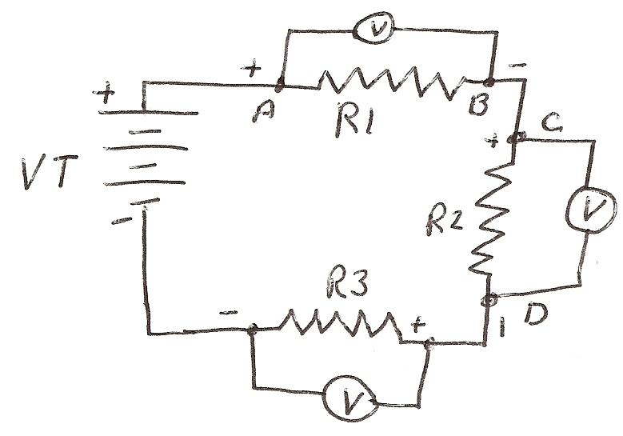
Each meter will take a small sample of the current, hence the charge and thereby the Joules/Coulomb required to move through each resistor. To do this the question becomes which lead of the meter goes on each end of the resistor to get a proper reading?
Consider this—Why would the charge move from point A to Point B in a circuit?
The current, assumed here to be the flow of a + charge, is moving toward the – terminal. So… Point A must be more + than point B, and C must be more positive than D, etc. This leads to a polarity for voltage measurement as above.
Another consideration is how do we calculate the values of V1, V2, V3? Well we have Ohm’s Law, V=IR and since the current is the same in each resistor
VT=I *R1 + I *R2 + I *R3
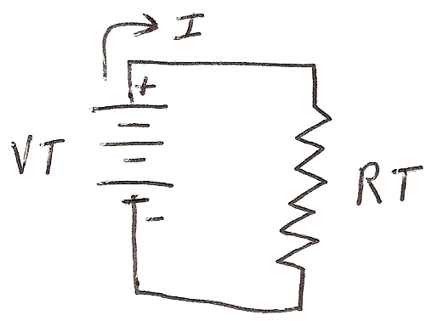
This is another form of KVL. It also shows that the voltage drop around a series circuit equals the total applied voltage. If we consider how this circuit looks viewed from the battery, the circuit would look like below. The battery outputs a current, I, into a total circuit resistance. From KCL we know this circuit is the same as in the prior series circuit. So

I *RT= I *R1 + I *R2 + I *R3 And when we divide out the current term, I, we get

RT= R1 + R2 + R3

So we see the complex series circuit could be replaced with RT and the battery would provide the same current as when the three resistors are there. RT is call the equivalent resistance.

Let’s look at an example calculation with real numbers.

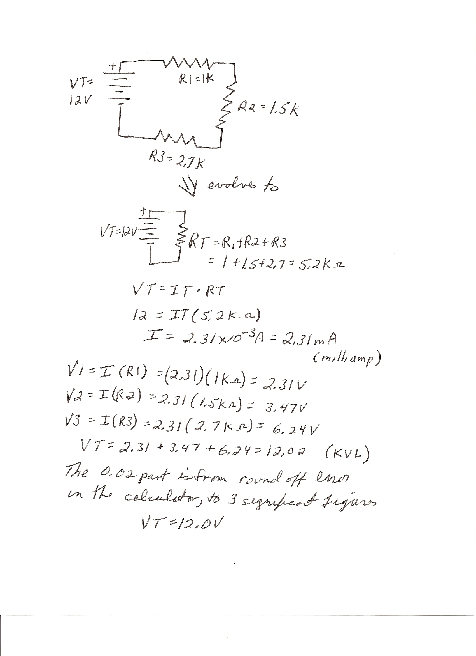
Parallel Circuits

A parallel circuit is one in which the current has multiple paths for return to the battery. However, remember KCL and KVL are lows of nature and parallel circuits must obey these the same as series circuits. By KCL we know that current into a device must equal current out of a device.

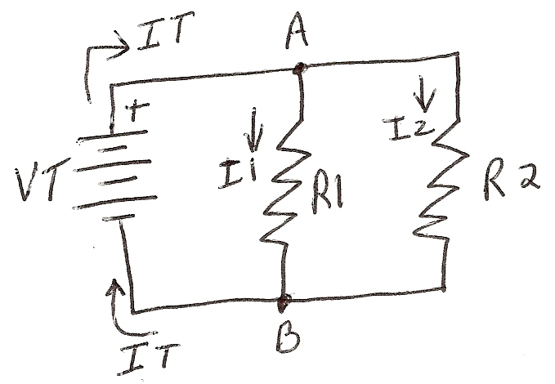
Consider the connection point A and B as a device. The current into A is IT for I total). But, the current out goes two ways some into R1 and some into R2. So by KCL

IT = I1 + I2

The current splits. Now ….How does it split? Imagine a voltmeter on R1 at points A and B. Since it is assumed all wires require no (or negligible) energy to get through, the total voltage VT is across R1 and R2. By Ohm’s Law

VT = I1 *R1 and VT = I2* R2

So, the current through R1 is gotten from
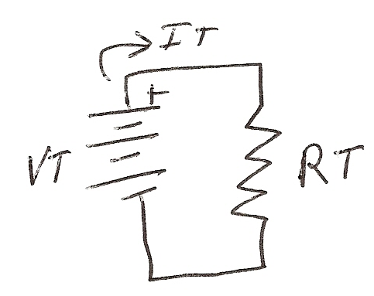
I1= VT/R1 and I2 = VT/R2 (see the magic circle)

Now let’s look at the “equivalent” circuit [How the battery sees things.].

Here IT = VT/RT and
IT = I1 + I2 so VT = VT + VT
RT R1 R2
If we divide both sides by VT we get
1 = 1 + 1
RT R1 R2
This is the famous (or notorious) reciprocal equation. Resistors in parallel can be replaced by one total resistance RT from the equation above. If you have 3, 4, 5 etc. in parallel you just add on the reciprocals. Now you see the importance of the 1/x key on the calculator.
If we limit our view to two resistors the equation will simplify (lots of algebra) to
RT = R1*R2 (or product /sum)
R1 + R2
Sometimes this equation is easier to use than the reciprocal for two resistors. Let’s look at an example with numbers…
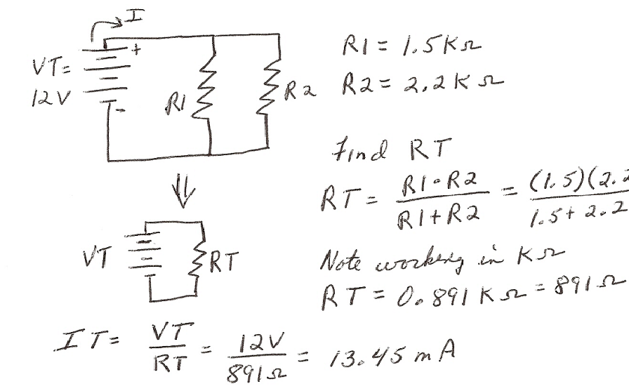

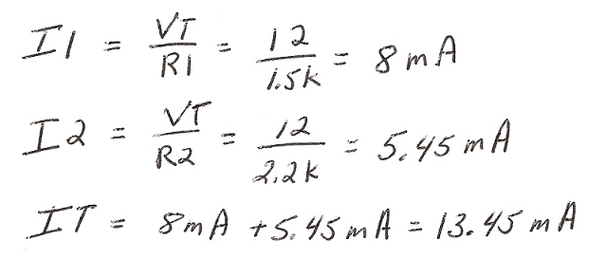

In summary, in parallel circuits:

- Voltage on parallel parts is equal.
- Current divides into each branch of a parallel circuit.
- The total resistance of a parallel combination is always less than the smallest in the parallel circuit.

Application:

- A group of resistors is in series. What is the total resistance for the values listed below:
- R1=1.5K Ω, R2= 330 KΩ
- R1= 2.7 KΩ, R2=4.7 KΩ, R3=1.5 KΩ
- R1=820 Ω, R2=1.2 KΩ

Note: the K stand for kilo and the Ω stand for ohms, so KΩ means kilohms or 1000 ohms. The Ω is the Greek letter omega.
- Two resistors are in series, 1.2 KW and 2.7 KW. They are connected to a 12 V battery. What is the equivalent resistance and total current?
- What is the equivalent resistance for the four examples below if connected in parallel?
(a) R1=1.5K Ω, R2= 330 KΩ
(b) R1= 2.7 KΩ, R2=4.7 KΩ, R3=1.5 KΩ
(c) R1=820 Ω, R2=1.2 KΩ
(d) R1=10KΩ, R2+10KΩ
- Two resistors, R1=2.7 KΩ and R2=3.3 KΩ. If connected in parallel to a 6 V battery, what is the current in each?

Combination Circuits

In electronics most circuits are a combination of both series and parallel parts. These circuits can be very, very complex. Later electronics classes will concentrate on this type of complex circuit, but in this class we will expect you to master a particular configuration.

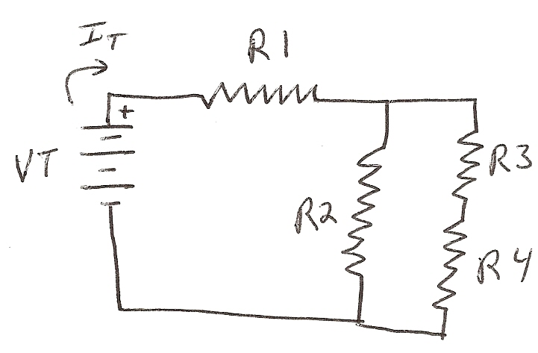
This involves a parallel section with one branch having series parts. The parallel section is in series with another resistor, all with a single battery source. Later classes will expand on this with greater complexity and more complex techniques of analysis. This is after all, an Introduction to Electronics.
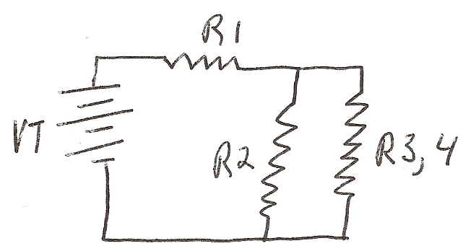
OK, what do we do with the circuit at the right? Notice R3 and R4 is series, so
R3 +R4 = R3,4 ( a single resistor.)
Note the notation scheme designed to keep track of the origin of the value.

Look at R2, it is in parallel with R3,4.
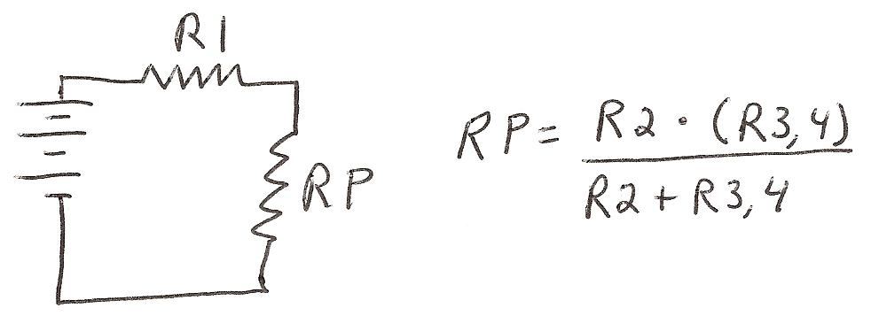

Now of course we can see that R1 is in series with RP. RT= R1 + RP
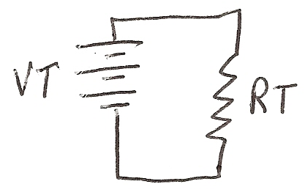
So here we are again at the basic circuit. I used above some notation schemes that have evolved over the years to state what is being done.

For example, with two resistors in parallel
RT = R1 // R2, read R1 parallel R2 this is calculated as
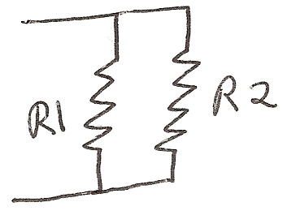

RT = R1*R2
R1+R2
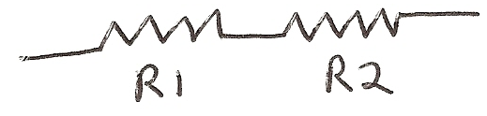
For two in series use RT = R1 + R2 = R1,2

Our circuit above would be described as
RT = R1 + R2 // R3,4

The key then to complex circuits is to redraw the circuit (several times) to reduce the complexity. Always start inside any parallel branch and workout. The approach is to start inside and workout as opposed to left to right or top to bottom. Redrawing is important and NOT a waste of time or paper!!
Let’s try an example with numbers:
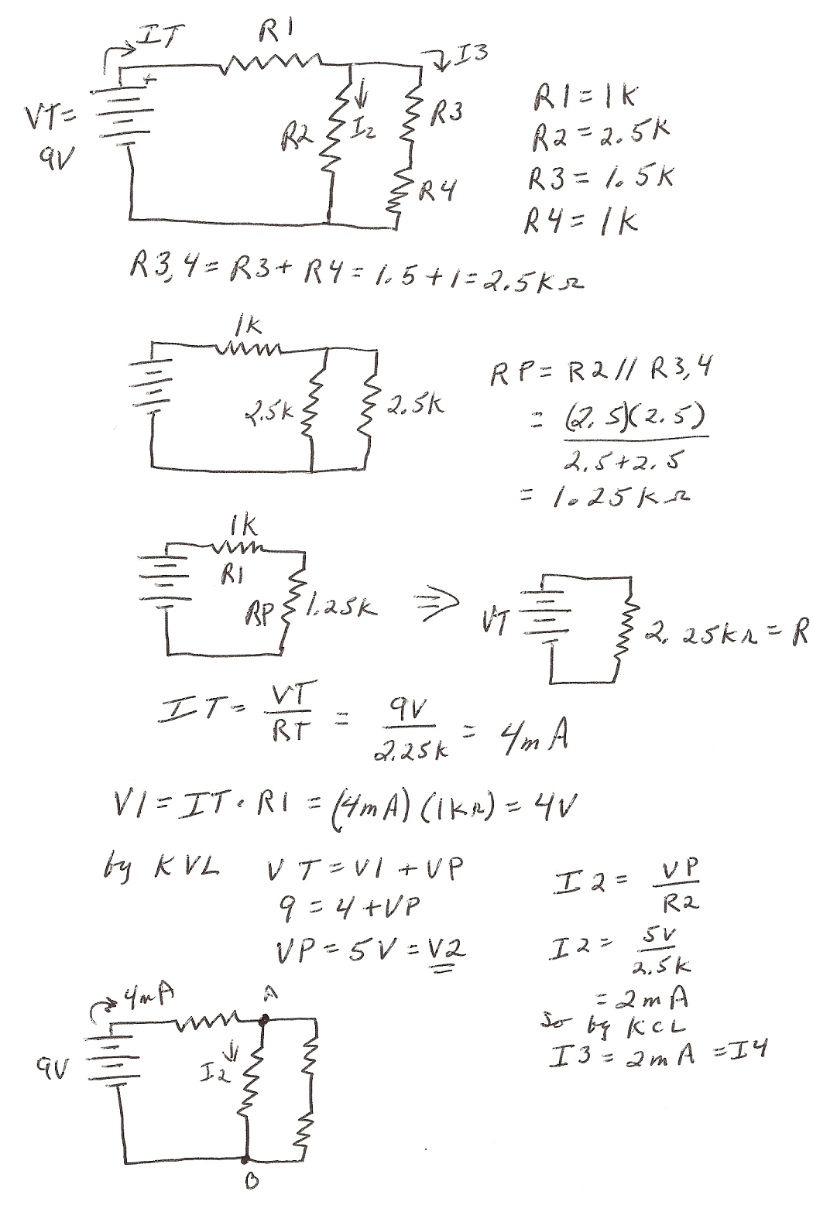
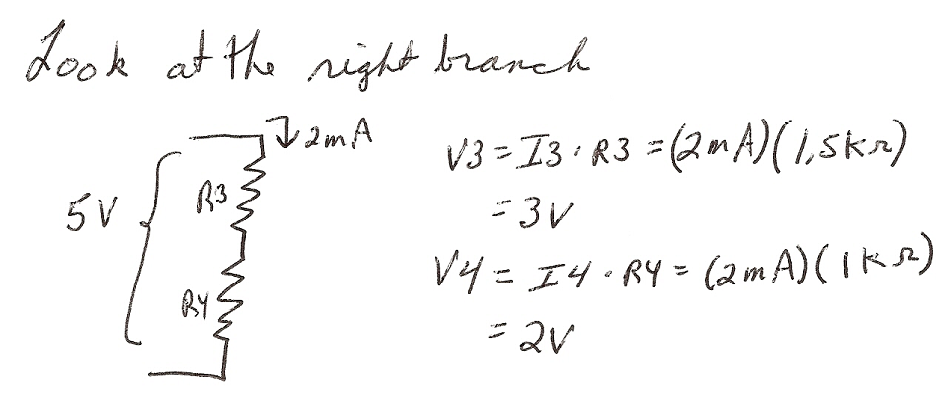

So we have all the values for every part of the circuit. This is the power of electronics. We can predict what is happening in every part. So we know what “right” operation is. If we don’t measure what is expected from the calculations, it gives us clues to where or what the problem is all about.

Applications:

- For the circuit below find the current in each branch of the parallel circuit.

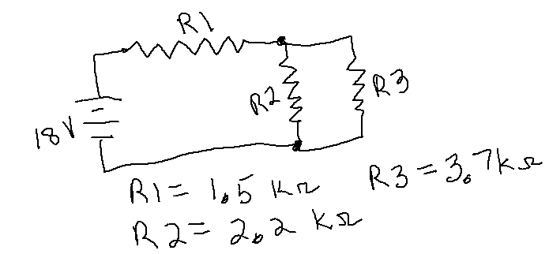

- For the circuit below find the value of V1, V2 and V3 with V=12volts
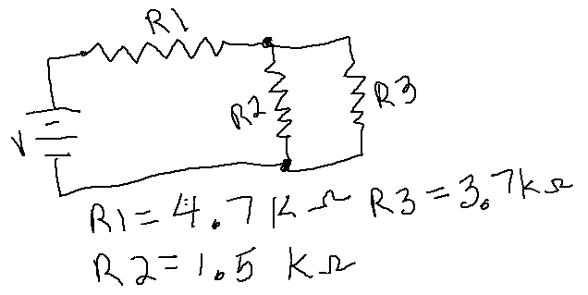

In the appendix of this text you will find several sections that can be helpful in solving these types of problems. The section on “How to Solve Like A Pro” relates to the steps demonstrated in the examples above. Also a section on Quantities and Units can help keep these terms straight.

Application: The Voltage Divider

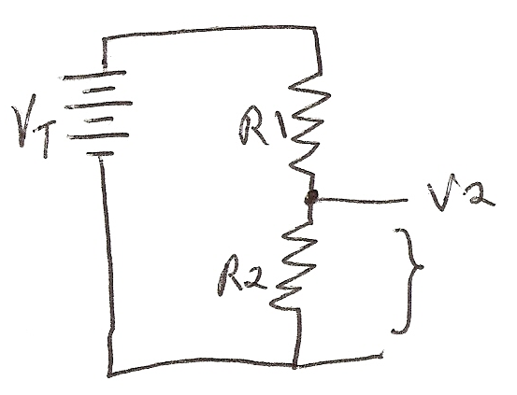
One of the most versatile circuits in electronics is called the voltage divider. It occurs in a variety of forms, but basically it involves applying a voltage and having the circuit break it down to a smaller amount. The basic circuit is below.

The voltage V2 is some fraction of the applied voltage VT. From KVL we know that

VT= V1 + V2 and IT = VT/RT where RT = R1 +R2

Now, IT = VT
(R1 +R2)
So V2 = IT * R2

V2 = R2 * VT
(R1 + R2)

V2 = R2 *VT
R1 +R2

Applications of the voltage divider
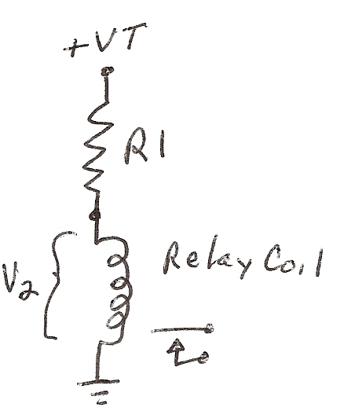

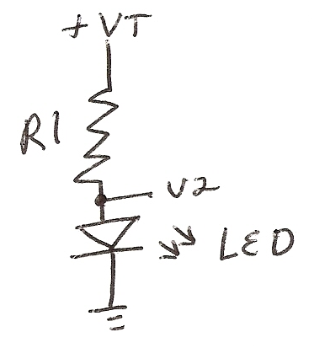

The relay will have a rated voltage, so R1 must drop the rest from VT. The LED is the same situation where the VLED is between 1.5 and 2 V.

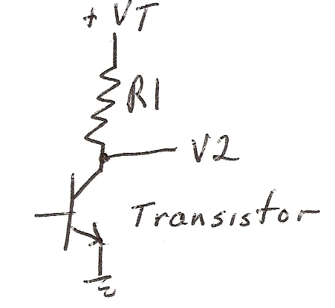
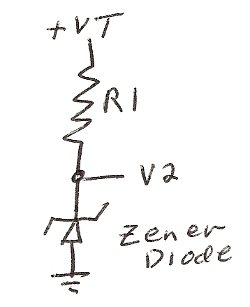
On the transistor this circuit is the final stage of many amplifier systems. The Transistor (or transient resistor) will allow the voltage to vary as a fraction of VT.

On the Zener Diode its function is to hold a rated voltage. R1 will change VT to allow the rated Zener value to stay constant.

Often the voltage divider is used to establish the operation of a sensor as show below are a photo sensor where the voltage will depend on the amount of light falling on the senor. With the thermal sensor the output voltage will be a function of the ambient temperature. These circuits make very good inputs to computers to measure real world quantities.
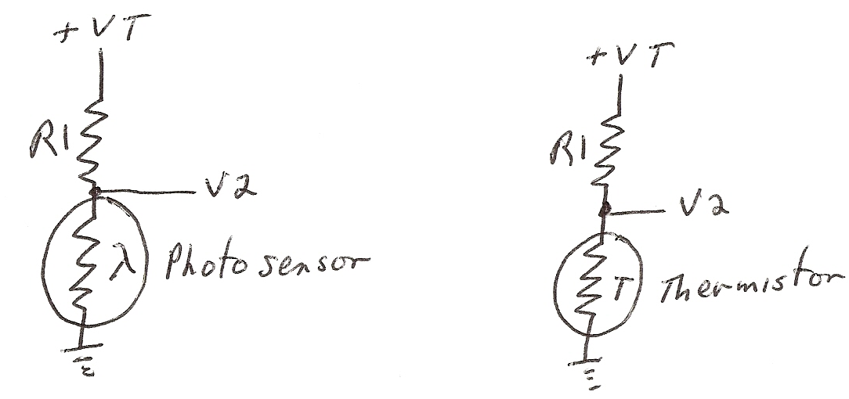

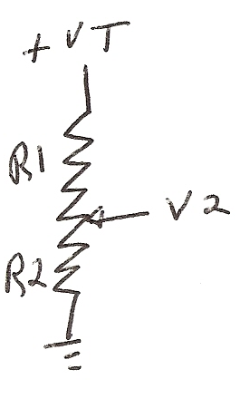
This last circuit is the volume control in radios, disk players, etc.

In later sections the details of selection of component values will be presented.

