Introduction to Mathematics for Electronics and Manufacturing

Number Bases and Signed Numbers

Dialog:

The most fundamental concept for math is positive and negative numbers. The concept extends from the number line.

Negative Numbers Positive Numbers
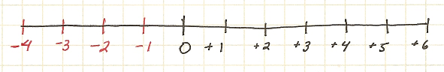
Here the positive numbers are those positions to the right of a reverence point (zero). A move to the left is in the negative direction. In electronics we apply this to voltages. A circuit may appear as shown below.

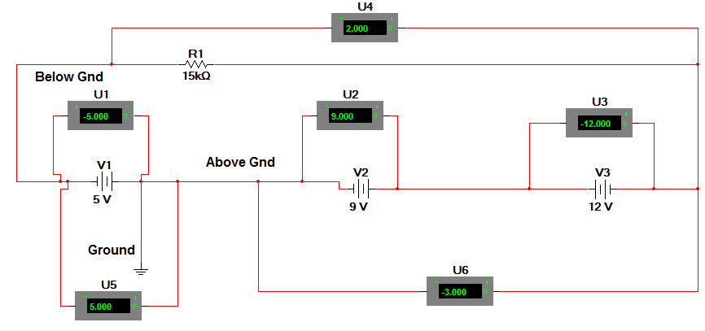

We make the measurements with respect to a fixed reference. This reference is usually referred to as ground since many times we use the earth ground as the common reference level. Now if the positive lead of a battery is connected to this ground then the other lead is said to be below ground and is represented as a negative voltage. Voltages are usually taken with the negative (black) lead connected to the ground. As you can see above U1 then reads a negative voltage. U2 reads a positive voltage. Since V3 is connected opposite to V2 the total voltage of the three –end to end- is only 2 volts as seen on U4.
Note that U1 and U5 read the same value but with different sign. This is because they have different reference points. U1 has its reference at ground (the negative lead of meter) and U5 has its reference connected below the ground and hence shows a positive reading when moving from reference to the (+) meter lead. The meter always reads with the assumption that (-) is connected to the reference point.

Thus by Kirchoff’s Voltage Law,
V1+V2+V3 = VT = V4
(+5V) + (+9 V) + (-12 V) = 2V
An application of signed numbers.

Application:

An addition calculator

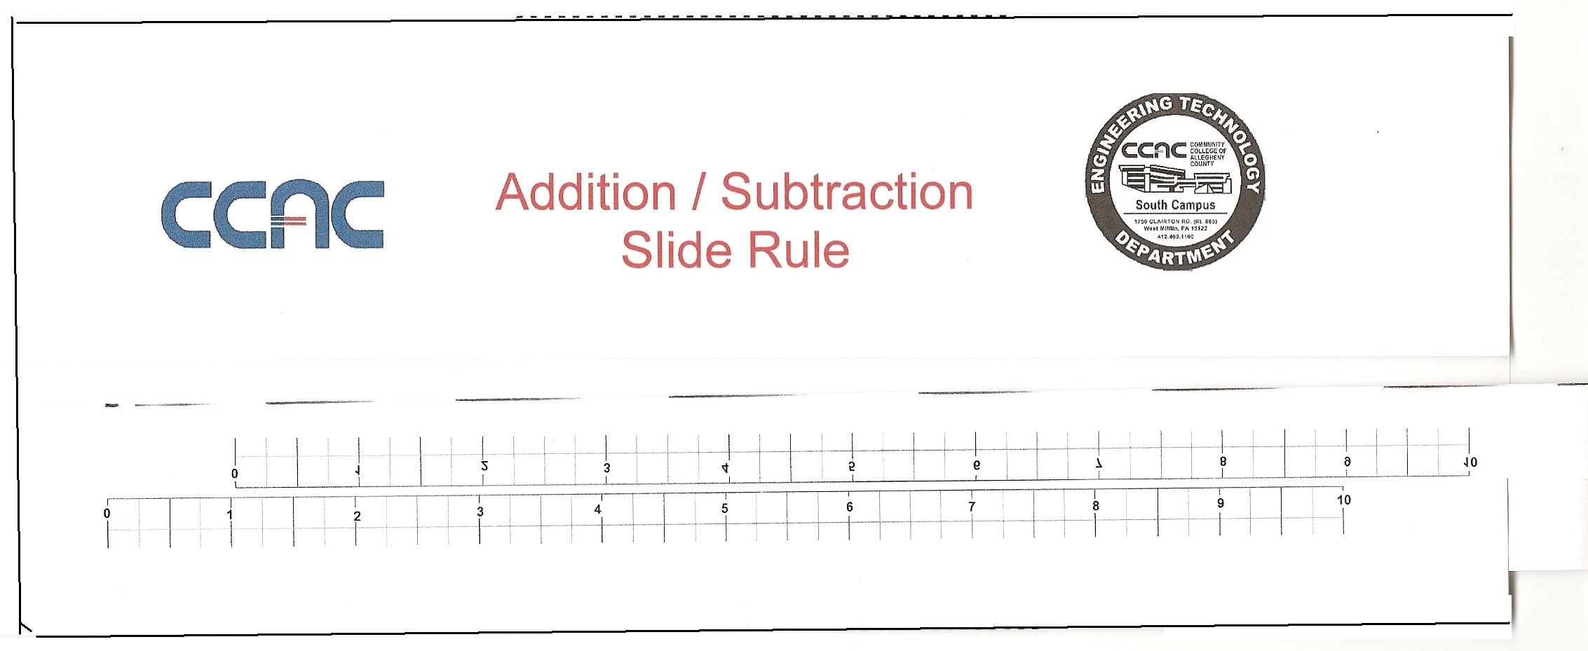
Prior to the invention of the electronic calculator a device called a slide rule was used. Various versions would do specific operations. Find the file labeled sliderule1.doc and sliderule2.doc and print the contents. Cut out the two rulers and place into the remaining portion to form an additive slide rule. A picture of the finished device is shown below. This is the first of several slide rules we will design and make in this module.

Solve each of the problems below and then repeat the calculations with the slide rule.

- +3 + (-2) 2) +4 + (+3)

- -4 + (-2) 4) +5 – (+3)

5) +5 – (-2) 6) +6 + (-2)

These numbers could also be battery voltages for units wired in series. In this sense we can view negatives as devices reversed from what was expected.

Another view of negative numbers could be in a monetary application. Suppose we have $50 in a checking account. Then we write a check for $60. The bank honors the check because we have an automatic overdraft feature on our account. Our new balance will be -$10. We have a deficit or debt now of $10. So the negative number represents our debt or the amount of money we need just to be broke!

Exploration:

Graphs and Number Lines

We have encountered graphs before in ERG100. The x-y graph is another application of signed numbers as shown in the figure below.

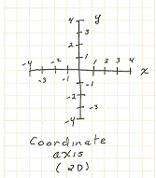

Positive values are represented as to the right and up. Negative values are to the left and down. We will refer to x,y pairs or coordinate pairs. For example, (-2,0) would be the point on the x axis to the left labeled -2. It is understood that the order of the pairs is (x,y). So location (-3, 2) would be left 3 and up 2. Each of these four areas are called quadrants of the x,y plane. In real space we would add a third dimension the z axis coming out at you , but that is hard to draw on a flat page.

Print out the file xypaper1.bmp and plot the points below on the graph paper.

x | y
-3 | -7
-1 | -3
0 | -1
1 | 1
3 | 5
5 | 9

Questions:
Do you see any trend to the data?

Any idea what the value would be if x=6?

Dialog:

Equations
Suppose we have the following situation:

3 + ? =7

And we ask the question what is the missing value. Most of us could figure we need the number 4. Now If instead of a question mark, we use a letter, say x, we would have

3 + x = 7

This would be a typical expression from the language called Algebra.

I used the term language because it can be viewed as a sentence just like in English.
This language describes how quantities relate to each other. These sentences are called equations.

In engineering we need to be able to make predictions about what will happen. To do this we need to quantify the situation. This leads to the use of equations. The equation will describe in a quantitative manner an electronic circuit or device. This allows prediction of how the device will behave in future applications.

In the case of our graph above it appeared that the data might be in a straight line. If we know the equation that produced the data, we could calculate any value pair we desired. In Engineering Seminar you studied that process. It might be helpful to review that information during this lesson. ( see the Engineering Graphics slides on the Web site.)

As a quick review, a straight line on a graph can result in an equation of the form

y = m*x + b
The x and y represent the ordered locations along the line. There are an infinite number of possible values on the line. The m term related to the angle or slope that the line takes in moving up on the graph. The b term is the location on the vertical axis that the line crosses. If we have the line drawn on the graph, we can read this value off the graph directly. The m or slope term is a bit more difficult to obtain. The technique is to draw a right triangle on the graph and determine (to the scale of the graph) the lengths of the sides. By dividing the vertical by the horizontal distance we can determine the “rate” of climb. For example if the ratio is 3/2 then for every 2 units on the x we go up 3. The slope would be listed as 1.5, since in engineering we prefer decimal notation when possible.

The sketch below will show you just such a line on a graph. (This was drawn using MathCad and y= 1.5 X+ 3

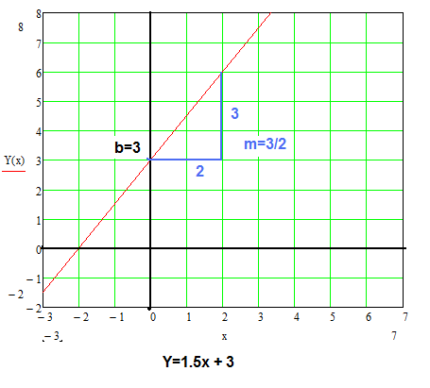

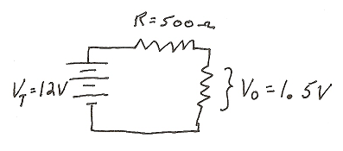
Many times we will have only one unknown quantity. In Algebra this is often represented with the letter x, y or z. However, in electronics the letters V, I and R are more common. This makes no difference to the math. So don’t get hung up on the letters used to represent the variable or unknown quantity. From the circuit below a typical equation from Kirchoff’s Law would be

V_{T}= I*R +V₀

12 = 500 (I) + 1.5

In this equation we do not know the value of the current I and it is represented in the equation as a letter. We would like to solve for this quantity.

To do this there are a few “rules” we must always follow when dealing with equations.

1.What ever is done to one side of an equation must be done on the other side. Add, Subtract, Multiply and Divide. Are the most common operations.
2. Do the above until only the variable letter is left on the left side of the equation.
3. Observe “order of operations” with respect to parentheses in the equations. Remember multiply and divide comes before add and subtract.

Below is a step by step application of this to the equation above.

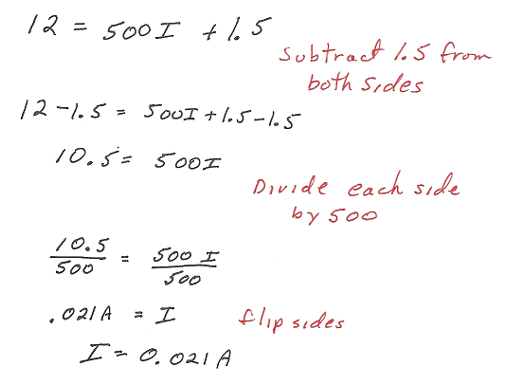

Often it is helpful to perform a “check” of the solution. This can be done by putting the value discovered into the equation and seeing that the left and right side are the same.

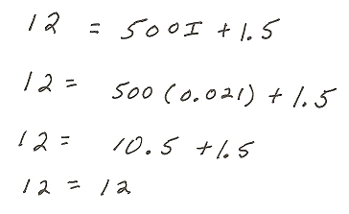

In addition to equations we often have formulas with which to deal. There is little difference between them, mainly in how we intend to use them. An equation can have the variable anywhere, but a formula has the unknown on the left side and other letters representing quantities on the right. We typically know the value of all those quantities.
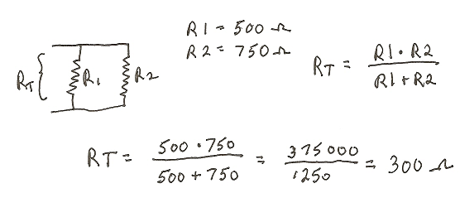
The formula for a parallel pair of resistors is below. The values of R1 and R2 are known.

However, sometimes the typically known variable is what we want, then it becomes an equation. One thing to get use to in engineering, and electronics especially, is that we will use equations and formulas that we are not fully knowledgeable about. That is we do not have to be able to derive the equation ourselves, if we trust the source of the equation –text book, expert, device manufacturer.

For example, from mechanical engineering the rate at which a black body will radiate heat is given by something called the the Stephan-Boltzman Law

R=S*T⁴

where S is a constant called Stephan’s Constant (5.6 x 10⁻⁸ Watt/(m²K⁴), T is the temperature in degrees Kelvin, and R is the heat energy lost.

Although we do not have extensive knowledge of the equation, we can calculate the results given the values of the quantities. Other types of equations are for charging of a capacitor

V=Vo*e^{-t/RC}

Or cooling of an ingot of steel.

(T_{now}-T_{room}) = (T_{high} – T_{room})(1 – e^{-t/τ})

MathCad Operations

Is there help for solving equations or doing computations? Yes, a program called MathCad is designed to solve nearly any mathematics problem both for a numerical value and symbolically.

In MathCAD it is important to specify the type of quantity or variable involved. There are two different ways of defining a variable by defining the variable locally or by defining the variable globally.
A locally defined variable is a variable that pertains to the current equation being used at that time. A local variable must be defined before the equation can be written.
Example 1: Find the area of these two boxes.
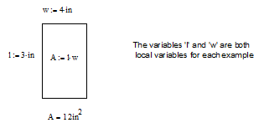

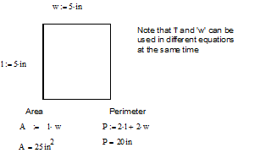

.
A globally defined variable is a variable that pertains to the document being used at that time. A global variable does not have to be defined before the equation can be written Example 2: The time it takes an object to drop a certain distance.
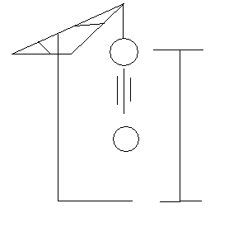
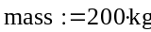
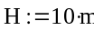
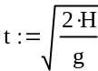
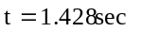
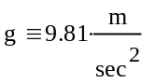
The variable 'g' is a global variable and the variables
'H' and 'mass' are local variables

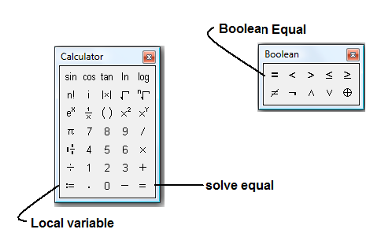
Take note of the three different types of equal signs used in this example. The equal sign that has a colon followed by an equal sign is the symbol for a local variable and a local equation. The equal sign that is made up of three horizontal lines is the symbol for a global variable and a global equation. The equal sign that looks like an equal sign is really an equal sign and is used to determine the solution. The numerical value of ‘t’ was determined in this manner. Notice since ‘g’ is a global variable it may appear before or after ‘t’ on the page. MathCAD seeks through the entire document for the global values. The local variables must always come before the equation in which they are used. Local variables that come after the equality will not affect the results that come before them on the page.

There are several ways to type these symbols. They are (a) use the keyboard, and (b) use the mouse and tool pallets

The tool pallets are shown here.

Using the keyboard
To get the symbol for an equal sign type shift+;
To get the symbol for a global equal sign type shift+ ~
To get an equal sign type =

Using the mouse and tool palette
To get the symbol for any of the equal signs go to View, Toolbars, and check Equation.
Choose the correct symbol off the list.

How to set up an equation
The way to set up an equation is as follows:
- Set up variables either local or global
- Define the equation in terms of the variables that were set

Example 3: The linear slope-intercept formula
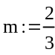
Slope of a line
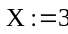
X-axis coordinate point
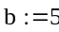
Scalar value
Linear formula
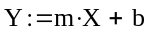
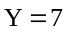

Using the keyboard, the way the linear formula is typed in is:

Shift+y Shift+; m Shift+8 Shift+x Shift+= b which yields

Now with the change of just one variable (‘m’ the slope of the line) the whole equation will rework itself to yield a new answer.
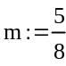
Slope of a line
X-axis coordinate point
Scalar value
Linear formula
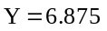

Example 4: How three different points on the same line would look
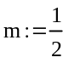
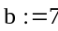
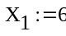
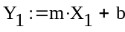
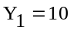
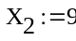
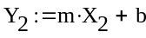
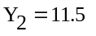
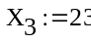
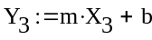
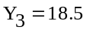

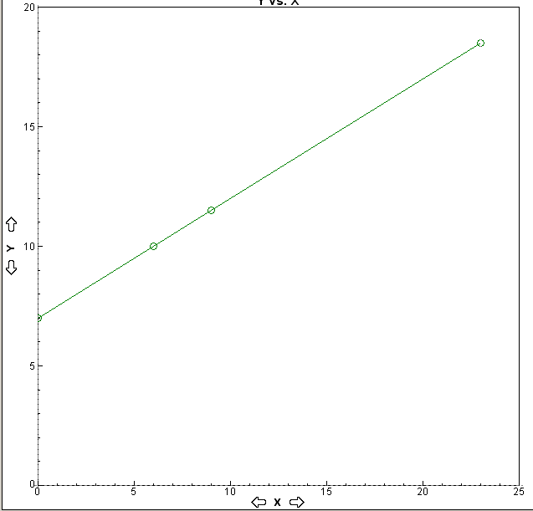

One final note, in solving a problem you may wish to place text on the screen. For example, label the top of the page with “Problem 1”. To do this, place the cross-hair at the place you wish the text to begin: select “Insert” at the top of the screen, then click on “Text Region”. Begin typing text at the red vertical cursor. Delete will erase typed items and clicking on a blank space below or above the text will end that text entry and return you to equation entry.

Application: Sample exercises

- Use MathCAD to find the area of a rectangle with a length of 10 and a width of 5.

- Use MathCAD to find the area of a circle with a diameter of 5.

- Using MathCAD, set up the equation for a straight line. Define m=3 as a local variable and b=3 as a global variable. Find Y for X=1.5

- Use MathCAD to find the value of R_{T} in the formula R_{T}=R₁*R₂/(R₁+R₂); if R₁=270 and R₂=330

- Using MathCAD to solve the equation y=2*x²+5*x-3. Use the quadratic equation to solve. (Hint: remember y=ax²+bx+c)

Advanced Algebraic Equations

With MathCAD it is very easy to do an equation that is based on a variable raised to a power or if the value needed for the equation is based on a series of numbers. The way MathCAD does equations that are raised to a power is as follows:

Example 1: y=a(1-x)²+b
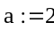
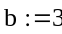
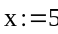
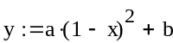
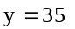

Now let’s say that you want the values for y related to the x values between -2 and +2. MathCAD considers this type of operation a mathematical function. A function does not imply a single answer, but a relation between the variables.

Example 2: y(x)=a(1-x)²+b
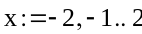
'x' is the independent variable
and has a range from -2 to +2.
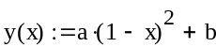
The function y(x) is dependent on the values of 'x'
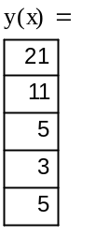
The answer is the set of values calculated
from the 'x' values. The number of calculated values is based on the step of the range values. In this example the step is one.

The range for Example 2 is defined as -2, -1, 0, 1, 2. The way MathCAD determines these numbers is by being given the first number in the range, the next value (this determines the step), and the last value in the range.

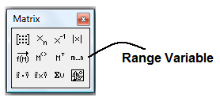
Using the tool pallet type the variable, the appropriate equal and the first value then click m..n on the pallet. And follow below.

For the keyboard, type in the range as follows: x Shift+; -2 , -1 ; 2
Type the function for the equation as follows: f ( x ) Shift+; a ( 1 – x ) Shift+6 2 Spacebar Shift+= b
To obtain the answer type: f( x ) =
An example of using a functional equation would be Torricelli’s Theorem as shown in Robert L. Mott’s book Applied Fluid Mechanics Third Edition.
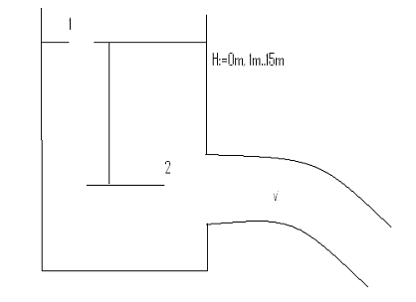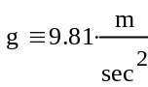

Torricelli’s Theorem Solution for H
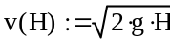
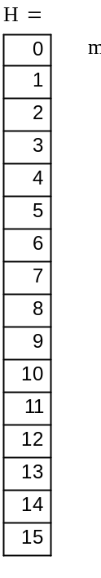
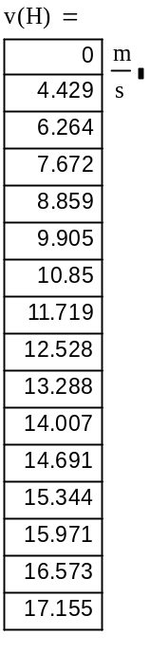
For this example, the calculation of
Torricelli's Theorem yields the velocities
of a fluid for varying fluid depths.

This information could then be used to
determine the discharge rate for a
given opening.

The ART of editing
Editing in MathCAD is easy. MathCAD editing falls into two categories, either formula editing or text editing. Text editing is the easier of the two. To edit text, click outside the text area, move the mouse to the text area that is to be edited and click the left mouse button at the point you wish to edit, then begin either typing new text, deleting, or modifying.
Formula editing is a little harder, but this is also where the ART comes in. There are two types of cursors employed to edit. The crosshair (in red) is used to locate a new formula, text region, plot region, or variable assignment. The insertion point is a blue L that allows the insertion or deletion of any single character. The placeholder box and insertion point are shown below:
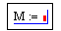The blue L that is around the placeholder indicates where in the formula new variable information can be placed.

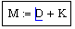The blue L indicates where in the formula editing can be done.

The insertion point is produced by clicking on a variable, function, or a number. To move around inside an equation or any other MathCAD formula object all that has to be done is use the arrow keys. The up arrow moves the selection point upward in the equation. The down arrow moves the selection point downward. The left arrow moves it to the left and the right arrow moves it to the right. The spacebar can be used to expand the area covered by the blue L.

The equation below needs a square root inserted for the square root to go in the correct place the blue insertion point needs to encompass everything that needs to be in that square root. When the square root button is then pressed it will insert it over everything that was marked.

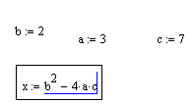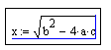

To place a minus sign in front of the square root you must use the arrows to position the blue L with the vertical line on the left and covering the whole equation. Then all that needs to be done is enter a minus sign.
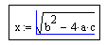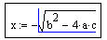
Rearranging the document

Your MathCAD document is no different than any engineering problem solving document. Information should flow down the page. This enables the reader to easily follow your line of reasoning and understand what you are trying to communicate. Suppose you did not leave sufficient room in your document to insert text or a drawing above your calculations? To move any expression or text region in MathCAD, just left click above and to the left of the expression or area that needs to be moved. Hold down the left mouse button and drag a dotted box over the items to be moved. Each region to be moved will be boxed separately. Release the mouse button. Next, left click the mouse inside any one of the boxes and hold it. You can now drag the entire set to a new position. WARNING: remember MathCAD’s local variables are page position sensitive. If you move an expression above the definition of its variables, you will get an error. If this happens, just move it lower on the page to redefine the local variables.

Application: Sample problems
For each problem below use MathCAD to find the set of solutions requested.

- The power dissipated in a resistor is given by P=I²*R where I is the current in Amperes and R is the resistance in Ohms. Find the power for a 270 Ohms resistor for the current from 0.1 Amperes to 1 Ampere in steps of 0.1 Amperes.

- The rate at which a black body will radiate heat is given by the Stephan-Boltzman Law R=S*T⁴ where S is a constant called Stephan’s Constant (5.6 x 10⁻⁸ Watt/(m²K⁴⁾ Calculate the rate for radiation loss as the temperature of a black body falls from 1000 degrees Kelvin to 500 degrees Kelvin in steps of 50 degrees Kelvin.

- If a thin rod is constrained at both ends and heated, it will attempt to expand. Since the constraints prevent expansion, a compressive stress will be produced in the rod. This stress is given by S=Y*a*(T₂-T₁) where S is the force/area or stress, Y is Young’s modulus, a is the coefficient of expansion, T₂ is the high temperature, and T₁ is the lower temperature. Find the stress produced in an aluminum rod as the temperature is raised from a base temperature of 300 degrees Kelvin to 500 degrees Kelvin in steps of 50 degrees Kelvin. Y=1.0*10⁷ a=2.4*10⁻⁵

- When fluid pours through a rectangular open channel under gravity, the flow rate in (ft³/s) can be determined by
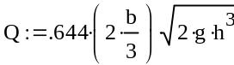 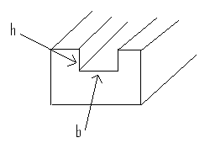The diagram of a weir.
This channel is called a weir. The variable b is the width of the weir, h is the height of water over the weir crest, and g is the acceleration of gravity. Make a table of data of the flow Q for heights from 1 to 10 feet if b=5 ft and g=32*ft/sec²

Graphing Results

In Engineering Technology and Science it is often necessary to produce a graph of the functional behavior of an equation. In the last chapter, we established data tables that could be used to graph the function. In this chapter MathCAD will bypass the data table and produce the actual graph…after all, one picture is worth a thousand words.
Graphs usually involve two different variables. The horizontal is the independent variable and the vertical is the dependent variable. The independent variable will be defined as a local range variable. For example t:=1,2..10. The dependent variable will be a local function of t. For example y(t):=3*t² + 2. To produce the graph of the expression, first place the crosshair at the location for the upper left corner of the graph and click once. Then select Insert then Graph from the menu bar at the top of the screen. From that menu, select X-Y Plot. At this, a box will appear at the location of the crosshair.
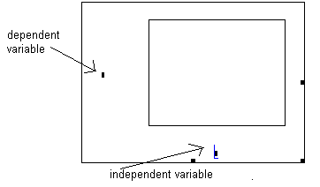
The blue selection L will be over the independent variable. Type the local range variable here, then press the left cursor 4 times to move to the dependent variable in the middle of the vertical axis. Type the function variable here exactly as it appears to the left of the := sign. The remaining marked locations are for changing the limits of the graph. Use the left or right arrow keys to position the marker over these areas and type the desired values or skip these to accept the MathCAD default decision. Our example is below.
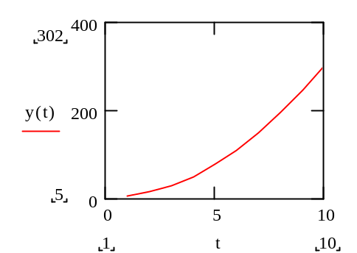
Graphing Trigonometric Functions

In Engineering Technology it is important to be able to work with Sine, Cosine, and Tangent functions. These are all available within MathCAD. One problem however is that the functions use the radian measure to compute the value associated with an angle. In electronics the angles are usually listed in radians so this would pose no problems. However, in other fields and in math classes it is more common to use degrees. MathCAD has a built in feature to convert degrees into radians. Whenever degrees are used, the ‘deg’ function is multiplied after it. For example:
Radians
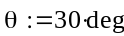
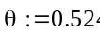

Radians (half way around is equal to Pi)
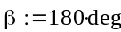
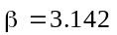

To demonstrate the graphing of a trig function look at the AC voltage given by the following equation:
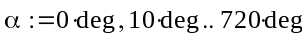
Note: amplitude is 5
and the phase angle
is 10 degrees.
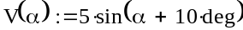
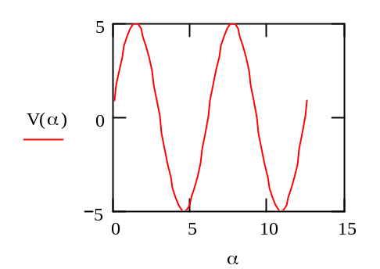
Note: the 'α'
value plotted in
radian measure

In electronics it is often necessary to plot the voltage versus degree or rotation. For this to occur in MathCAD, we must define an angular function. Then we plot this function on our horizontal axis. This will override the default of MathCAD to plot in radians. For example:
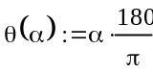
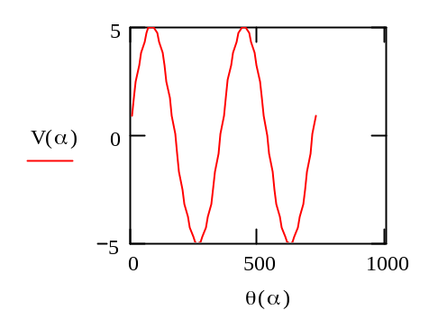
Note: See how the Theta
function allows plotting to
720 degrees. Mathematically
these are referred to as
parametric equations.

The Exponential Function

In several Engineering Technology fields the exponential function is important. It describes how the charge changes in a capacitor and how the temperature changes in a cooling slab of metal. There are two ways to deal with this function. First, the function exp(x) may be used. This expression may be familiar from spreadsheets. It is also possible to use the ‘e’ with an exponent.
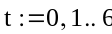
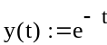
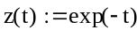
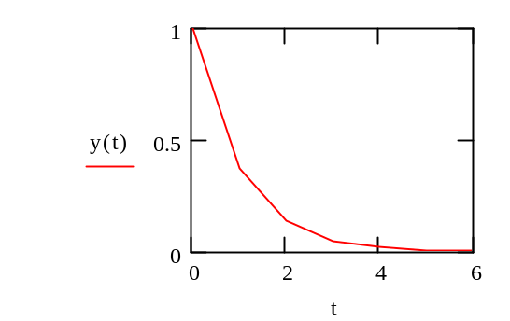
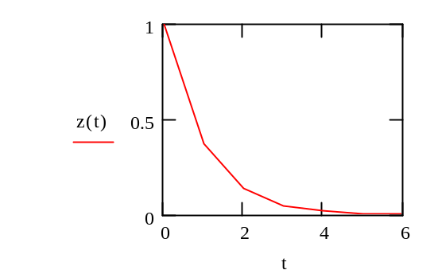

The two graphs look the same because they are functionally the same. Also realize this means that the letter ‘e’ has a special meaning in MathCAD and you should not use it for any other reason.

Combining equations
In some situations it is desirable to combine several equations to get the final result. Damped harmonic motion is a good example. We see this type of motion in the bounce of a car, the dying out of a swing’s amplitude, and the decrease of the loudness of the tone of a tuning fork. The equations are:
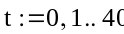
The sine wave vibration
The damping term
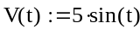
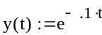
The equation of the combined motion
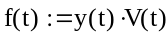
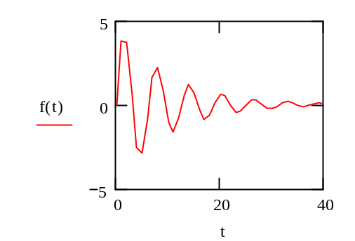

How do we solve linear equations for a single unknown. The section below is from the help menu of MathCAD.

1. In your worksheet window, type the equation using the Boolean equal sign. To do so, type [Ctrl] [=] or click the Equal To button on the Boolean toolbar.
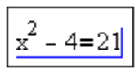
2. Click anywhere in the equation and press [Ctrl] [Shift] [.] to insert a placeholder followed by the symbolic equal sign.
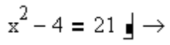
3. Type the keyword "solve" in the placeholder and press [Enter] to see the result displayed.
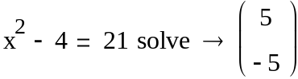
Note: If the equation contains more than one variable, you must also type a comma after "solve" and then type the variable you want to solve for in the placeholder that appears.

The following is an example of solving for a variable. First input the equation, the steps will look as below:

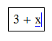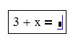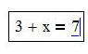
We have used here a special form of the equal sign. It is called a Boolean Equal. You produce it by Pressing the Control Key at the same time as the equal key – step one above.

Then place the curser anywhere in the equation and press the keys Control – shift- period all at once (see step two above.) When the enter key is pressed the answer will appear at the right of the equation as shown.
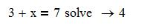
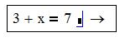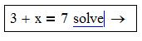
Use this technique to solve all of the sample equations presented.
Sample equations:

- 2*x + 17 = 4

- 3.7 * V + 5.12 = 12.5

- 7 * y – 14 = 3.9

- 16 -3 * R = 9

- 2.7 *A + 12 = 17

I used “ugly” numbers above because in engineering we seldom have integers in our equations. In a Math class the examples usually have integer numbers and the answers will be either whole numbers or common fractions. The solutions for these are in file pset1.mcd .
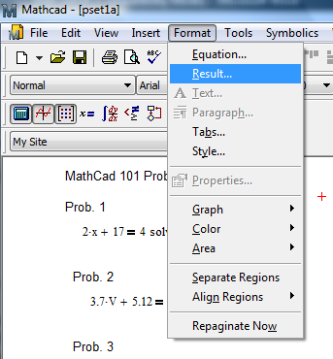
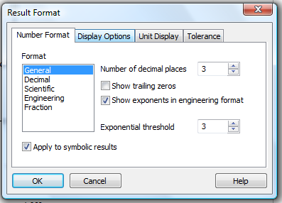
In the file the answers are given to way to many decimal points. To force the display to something reasonable for electronics, say 3 decimal points, click on Format> Results and then set the screen as shown. Be sure to check off the box as shown.

File pset1a.mcd shows the result of this setting.

Application:

To demonstrate that we understand the processes above, solve the five equations below using only paper and pencil. Fill in your answers to the data box provided. Then – only after the hand effort- use MathCad to find the solutions and enter those values into the data box.

- 3*R +2=12

- 14=6.5 *A -7

- 9 -2.7*Q =3

- 18*x +5 = 12

- 5.6 + 3*L = 17

Data Results:
Enter the unknown value in each square below.

Equation # | Hand Method | MathCad Method
1 (R=)
2 (V=)
3 (Q=)
4 (x=)
5 (L=)

Another trick is that the equation can substitute values as it solves the equation.
For example:
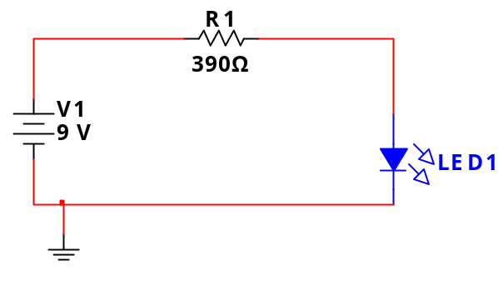
This is the general circuit for the LED.
Below is the solution form MathCad for the 9V shown and for two other values.

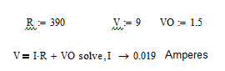

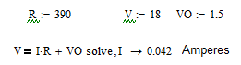
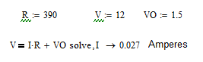

The Mathcad file LEDcirc.mcd will provide the above solution. Note that the solve has had the variable name listed for which we wish to solve. This will work for any equation with multiple values involved. In Introduction to Electronics the goal is be able to solve the following circuit :
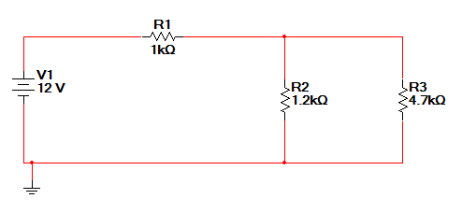

Suppose we wish to solve for total current. We need the total resistance and then can solve for the current. In MathCad this will look like the following.

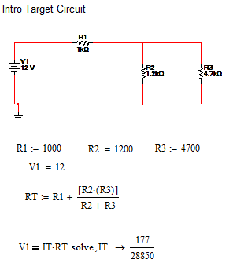

This is file serpar circuit.msn on your course site. The fraction at the end is easily converted to a decimal of 0.0061 Amperes. The solve feature finds an exact solution if possible, and a decimal would be only approximate. Notice that with the MathCad solution the steps are in agreement with the Process described in the paper on Solving Problems Like A Pro.

